CSS ISLAMIC STUDIES · MA
بِسْمِ ٱللَّهِ ٱلرَّحْمَٰنِ ٱلرَّحِيمِ
The Master Anatomy
The syllabus, the twelve papers of 2015–2026, and the plan — the map you read before anything else
Nine topics built from the seven syllabus heads. Every descriptive question (85, including the short-note options) and every recovered MCQ (223) set between 2015 and 2026 has been placed, counted and read for its pattern. This document tells you what is asked, how often, in what words, what has never been asked yet, and how an Islamic Studies answer earns its marks.
Compulsory paper · 100 marks · pass mark 40. After English Essay and Precis, Islamic Studies is the paper that fails the largest number of candidates. It is not failed for lack of faith or knowledge; it is failed for lack of structure, lack of evidence and lack of relevance. These notes are built to fix exactly those three things.
Every heading is taken from the words of the question. Every point carries its evidence — the Quran first, then the Hadith, then the scholars — inside the point itself, never in a separate list.
Edition of September 2026 · covers the papers of 2015–2026 · written for CSS 2027 and after
Contents
HOW TO BUILD THE CONTENTS
The Contents below is left empty on purpose. In Microsoft Word, right-click anywhere on the grey line below and choose Update Field → Update entire table → OK. The full table of contents with page numbers will appear.
On a Mac: right-click (or Control-click) the line → Update Field. If you edit the notes later, repeat this step to refresh the page numbers. You can also press Ctrl + A then F9 (Windows) to update every field in the document at once.

How to Use This Document 8
What this document is 8
Who it is written for 8
The family of documents 8
How the pages are built 9
The rules these notes keep 10
The reading order 11
Part Zero — Islamic Studies from Zero 12
0.1 What this paper is — and what it is not 12
0.2 Islam in one picture: Iman, Islam and Ihsan 12
0.3 The two sources — and how to quote them 14
The Quran 14
The Sunnah and the Hadith 14
How the references are written in these notes — and in your paper 14
0.4 How Islam makes law — the sources in one figure 15
0.5 The words you must know before anything else 16
Belief (T1) 16
Worship (T2) 17
Sirah (T3) 17
Rights, society and civilization (T4–T5) 17
The world and extremism (T6–T7) 18
Governance and law (T8–T9) 18
0.6 The whole syllabus in twenty minutes 19
Topic 1 · Introduction to Islam and the Islamic Beliefs 19
Topic 2 · Islamic Worships (Ibadat) and Their Impact 19
Topic 3 · The Sirah of the Prophet ﷺ as Role Model 19
Topic 4 · Human Rights, Human Dignity, Women and the Family 20
Topic 5 · Islamic Civilization and Culture 20
Topic 6 · Islam and the World: the West, the Ummah and Pakistan 20
Topic 7 · Extremism, Terrorism, Sectarianism and Jihad 20
Topic 8 · Public Administration and Governance in Islam 20
Topic 9 · The Islamic Code of Life: Sources of Law and the Islamic Systems 20
0.7 The time-line behind the paper 20
0.8 Names and honorifics 21
0.9 Six habits of mind for an Islamic Studies paper 22
Part One — The Paper Itself 23
1.1 Where Islamic Studies sits in CSS 23
1.2 The syllabus, word for word 23
1.3 The reading list — which books actually help 25
Beyond the list — the sources these notes also draw on 26
1.4 How the paper is built 26
Part I — the objective questions (MCQs) 26
Part II — the descriptive questions 26
The 2015 exception 26
1.5 The marks and the minutes 27
1.6 Why candidates fail — and how to be in the other group 27
1.7 The twelve papers at a glance 28
Part Two — Nine Topics: Rebuilding the Syllabus 30
2.1 Why nine topics — and why these nine 30
2.2 From seven heads to nine topics — the full mapping 31
2.3 The contemporary layer — the hot topics each topic carries 31
2.4 The two documents each topic gets 32
The Knowledge Base (TnKB) 32
The Question Answers (TnQA) 32
2.5 The compiled volumes — and the Prediction Papers 32
Part Three — The Record: What Has Been Asked, 2015–2026 34
3.1 How the record was built 34
3.2 The heat map 34
How to read it 34
3.3 How much each topic weighs 35
3.4 The repeat engine 35
The families asked three times or more 36
The families asked twice 38
The families asked once 38
Exact and near repeats 38
3.5 The leaks between topics 39
3.6 The blind spots — syllabus lines never asked, 2015–2026 40
3.7 Beyond the syllabus — what the examiner asked that the syllabus never names 40
3.8 The objective paper, 2015–2026 41
What the MCQs teach 41
MCQ facts asked more than once 41
3.9 How the questions are shaped 42
3.10 The command words, decoded 42
3.11 What changed between 2015 and 2026 43
3.12 Where the next paper could come from 43
Tier 1 — prepare to full-answer depth from every angle 43
Tier 2 — prepare to a full plan and a strong short answer 43
Tier 3 — the blind spots most likely to be broken 44
Part Four — The Nine Topic Dossiers 45
T1 · Introduction to Islam and the Islamic Beliefs 45
What the syllabus asks for 45
What the examiner has asked 45
What the record reveals 45
The contemporary layer 45
Blind spots and five likely questions 46
The core evidence in one page 46
What the T1 documents will carry 47
T2 · Islamic Worships (Ibadat) and Their Impact 48
What the syllabus asks for 48
What the examiner has asked 48
What the record reveals 48
The contemporary layer 48
Blind spots and five likely questions 48
The core evidence in one page 49
What the T2 documents will carry 50
T3 · The Sirah of the Prophet ﷺ as Role Model 50
What the syllabus asks for 50
What the examiner has asked 50
What the record reveals 51
The contemporary layer 51
Blind spots and five likely questions 51
The core evidence in one page 52
What the T3 documents will carry 53
T4 · Human Rights, Human Dignity, Women and the Family 53
What the syllabus asks for 53
What the examiner has asked 53
What the record reveals 54
The contemporary layer 54
Blind spots and five likely questions 54
The core evidence in one page 54
What the T4 documents will carry 56
T5 · Islamic Civilization and Culture 56
What the syllabus asks for 56
What the examiner has asked 56
What the record reveals 57
The contemporary layer 57
Blind spots and five likely questions 57
The core evidence in one page 57
What the T5 documents will carry 58
T6 · Islam and the World: the West, the Ummah and Pakistan 59
What the syllabus asks for 59
What the examiner has asked 59
What the record reveals 59
The contemporary layer 59
Blind spots and five likely questions 59
The core evidence in one page 60
What the T6 documents will carry 61
T7 · Extremism, Terrorism, Sectarianism and Jihad 62
What the syllabus asks for 62
What the examiner has asked 62
What the record reveals 62
The contemporary layer 62
Blind spots and five likely questions 63
The core evidence in one page 63
What the T7 documents will carry 64
T8 · Public Administration and Governance in Islam 64
What the syllabus asks for 64
What the examiner has asked 64
What the record reveals 65
The contemporary layer 65
Blind spots and five likely questions 65
The core evidence in one page 65
What the T8 documents will carry 66
T9 · The Islamic Code of Life: Sources of Law and the Islamic Systems 67
What the syllabus asks for 67
What the examiner has asked 67
What the record reveals 67
The contemporary layer 67
Blind spots and five likely questions 68
The core evidence in one page 68
What the T9 documents will carry 69
Part Five — How an Islamic Studies Answer Scores 70
5.1 What the examiner is actually marking 70
5.2 The nine moves of a high-scoring answer 71
Move 1 — the answer map (90 seconds) 71
Move 2 — opening with evidence 71
Move 3 — the introduction (4–6 sentences) 71
Move 4 — headings from the question words 72
Move 5 — evidence inside every heading 72
Move 6 — a figure 72
Move 7 — the contemporary / Pakistan angle 72
Move 8 — the misconception or critique answered 72
Move 9 — the conclusion 72
5.3 The answer map — the house rule 72
How to build it — five steps 73
5.4 The introduction that earns marks 73
5.5 Headings that repeat the question 74
A worked heading tree — CSS 2019 Q2 74
More examples: from question to headings 75
5.6 Evidence — how to use the Quran and Hadith in the exam 76
The rules of evidence 76
Which scholars to quote 76
5.7 Figures in an Islamic Studies answer 77
Twelve master figures to practise 77
5.8 The contemporary and Pakistan angle 78
5.9 Sensitive questions — how to stay safe 78
5.10 Short notes — ten marks each 78
5.11 Twelve mistakes that cost marks 79
5.12 The objective part in thirty minutes 79
Part Six — The Plan 80
6.1 A sixteen-week plan 80
6.2 How to use each document 80
The Knowledge Base, in three readings 80
The Question Answers, in three passes 81
6.3 Memorising the verses and ahadith 81
6.4 The last fortnight 81
6.5 The day of the paper 81
6.6 After the nine topics 82
Appendix A — Every Descriptive Question, 2015–2026, by Year 83
2015 — old scheme: attempt five of eight, 16 marks each 83
2016 — attempt four of seven, 20 marks each 83
2017 — attempt four of seven, 20 marks each 83
2018 — attempt four of seven, 20 marks each 84
2019 — attempt four of seven, 20 marks each 84
2020 — attempt four of seven, 20 marks each 84
2021 — attempt four of seven, 20 marks each 85
2022 — attempt four of seven, 20 marks each 85
2023 — attempt four of seven, 20 marks each 85
2024 — attempt four of seven, 20 marks each 86
2025 — attempt four of seven, 20 marks each 86
2026 — attempt four of seven, 20 marks each 86
Appendix B — The Prediction Paper Format 88
Appendix C — Sources and Editorial Note 89

How to Use This Document

What this document is
This is not a book of Islamic Studies. It contains very little of the subject itself. It is the map you study before you study — and the map you come back to in the last fortnight, when you have to decide what to revise.
It does five jobs:
1. It explains the paper. What the syllabus says, how the paper is printed, how many questions you answer, how much time each gets, and how marks are actually earned.
2. It dissects the record. Every descriptive question from 2015 to 2026 (85 questions, with the short-note parts that could be recovered) and every recovered MCQ (223 items) has been tagged by topic, by family and by command word.
3. It rebuilds the syllabus into nine topics. The seven syllabus heads are uneven: some hold one line, one holds eight. They are rebuilt into nine balanced topics, each weighted by how often the examiner visits it.
4. It sets the method. How an Islamic Studies answer is built: the answer map, headings from the question words, evidence inside every heading, figures, the contemporary angle, and the conclusion.
5. It gives you a plan. A sixteen-week timetable, a memorisation routine for the verses and ahadith, and the drill for the day of the paper.

Who it is written for
It is written for someone who has studied Islamiat at school and college but has never written a twenty-mark answer for an examiner who reads three hundred scripts in a week. It assumes you are a believer who knows the basics; it does not assume you know how to prove them on paper.
- Every technical term is explained the first time it appears, and again in the word tables of Part Zero.
- Key terms you must be able to define are printed in bold green, like Tawhid; dates and numbers you must memorise are printed in bold navy, like 10 AH.
- The English is deliberately simple. Where a scholar's words are worth quoting in the exam, they are given in full and explained.
- Arabic is always followed by an English translation and a short reference. You are never expected to write Arabic you are not sure of.

The family of documents
This Master Anatomy is the first document of the set. Each of the nine topics then gets two Word documents, and when all nine are finished, five combined documents are compiled from them.
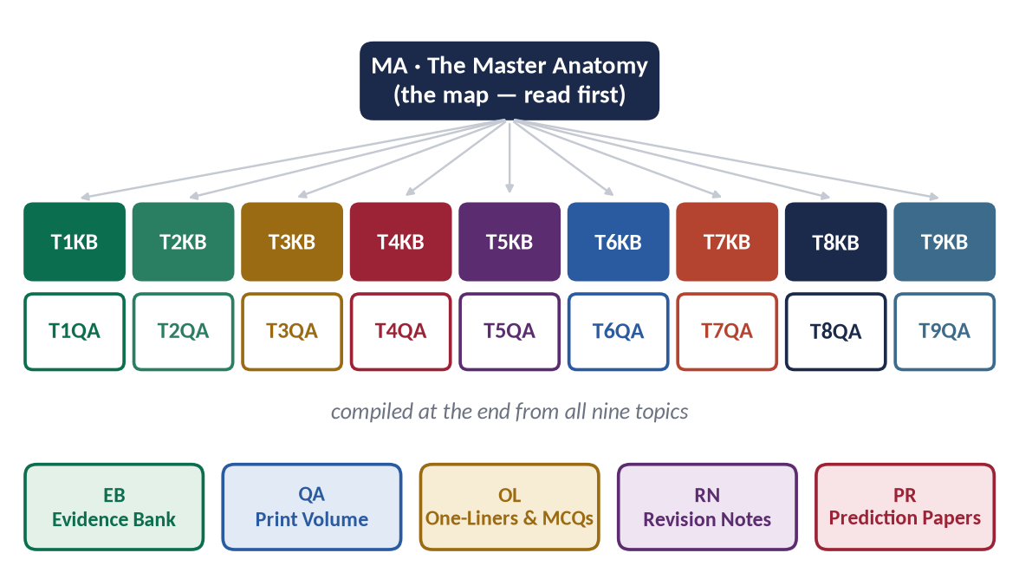
Figure 1 · The family of documents. The Master Anatomy maps the paper; each topic has a Knowledge Base (KB) and a Question Answers (QA) document; five volumes are compiled from all nine topics at the end.
Code | Document | What it does
MA | The Master Anatomy | This document: the paper, the record, the nine topics, the method, the plan.
TnKB | Topic Knowledge Base (T1KB … T9KB) | Everything you need to know for the topic, told simply, with deep headings (up to five levels), evidence inside every point, figures, the contemporary challenges and hot debates, five likely questions, one-liners and a revision sheet.
TnQA | Topic Question Answers (T1QA … T9QA) | Every past-paper question of the topic answered as a model: answer map, decoding of the question, headings from the question words, evidence in every heading, figures and conclusion.
EB | The Evidence Bank (compiled at the end) | Every Quranic verse, hadith and scholarly view used in all nine topics, collected and arranged topic by topic and sub-topic by sub-topic, for memorisation.
QA | The Question Answers print volume | All nine TnQA documents in one volume, in syllabus order.
OL | The One-Liner and MCQ Bank | The one-liners of every KB plus the MCQ facts, arranged for the objective part.
RN | The Revision Notes | The revision sheets of all nine topics: the whole paper in a few dozen pages for the last week.
PR | The Prediction Papers (Sets 1–3) | Three complete papers set exactly as FPSC prints them — 20 MCQs and 7 descriptive questions each — with full model answers.

How the pages are built
Every document in the set uses the same page furniture, so you always know what you are looking at. The most important piece is the evidence card. There are three kinds, and they always sit inside the point they prove:
✦ QURAN
﴿وَمَا خَلَقۡتُ ٱلۡجِنَّ وَٱلۡإِنسَ إِلَّا لِيَعۡبُدُونِ﴾
“And I did not create the jinn and mankind except to worship Me.” (Adh-Dhariyat, Quran)
➜ The point it proves is always written after the arrow — this is the sentence that turns a quotation into an argument. Here: the purpose of human life is worship (ibadah) in its widest sense.

✦ HADITH
إِنَّمَا الْأَعْمَالُ بِالنِّيَّاتِ، وَإِنَّمَا لِكُلِّ امْرِئٍ مَا نَوَى
“Actions are judged only by intentions, and every person will have only what he intended.” (Al-Bukhari and Muslim)
➜ A gold card is a hadith. The reference names only the collection, as you will write it in the exam.

✦ SCHOLARLY VIEW
Allama Muhammad Iqbal · poet-philosopher, Pakistan's national thinker
In The Reconstruction of Religious Thought in Islam, Iqbal calls Ijtihad 'the principle of movement in the structure of Islam' — the means by which a final revelation meets a changing world.
➜ A blue card is a scholar's view. When the exact words are well-known they are given in quotation marks; when they are not, the view is summarised in plain English — never invented.

Around the cards you will meet five kinds of boxes:
Box | What it means
TRAP | A mistake candidates commonly make — a weak hadith, a misquoted verse, a wrong date, an angle that annoys examiners.
EXAMINER'S EYE | What the examiner is looking for in this question or topic, and how to give it to him or her.
HOT DEBATE | A contemporary challenge, narrative or discourse — Islamophobia, feminism, AI, climate, riba, sectarianism — with the balanced Islamic answer.
PAKISTAN ANGLE | The Constitution, the institutions, the laws and the data that make an answer applied rather than abstract.
REMEMBER | A fact, list or line worth memorising word for word.

The rules these notes keep
Because Islamic Studies touches faith, and because you never know who your examiner is, every document in this set keeps the same rules:
1. The Quran first. Every Quranic verse is printed from a verified Uthmani text, letter for letter, with a standard simple-English translation of its meaning. It is referenced only as (Surah, Quran) — for example (Al-Baqarah, Quran).
2. Authentic Hadith only. Ahadith are taken from the well-known collections — Al-Bukhari, Muslim, Abu Dawud, Al-Tirmidhi, Al-Nasa'i, Ibn Majah, the Muwatta of Imam Malik and the Musnad of Imam Ahmad — and referenced by collection only, for example (Al-Bukhari). Famous sayings that are weak or wrongly attributed are flagged, not used.
3. No maslak, no sect, no controversy. No school of thought is attacked or promoted; controversial personalities and disputed questions are left out. Where a fiqh ruling is needed, the Hanafi position is given, because it is the school of the majority in Pakistan — and the other schools are mentioned respectfully where they differ.
4. Scholars support; they never replace. A scholar is quoted after the Quran and Sunnah, never instead of them. The scholars quoted are those accepted across the Muslim world, the authors on the FPSC reading list, and respected non-Muslim observers.
5. Simple English. Short sentences. One idea per sentence. Every Arabic term explained.
EXAMINER'S EYE · WHY NEUTRALITY SCORES
The examiner may be a traditional scholar, a university professor, a retired civil servant or a modern-minded academic. An answer that attacks a sect, praises a controversial figure or takes a side in a disputed question can lose marks with any of them. An answer that argues from the Quran and the Sunnah, with respect for all schools, cannot lose with any of them.

The reading order
1. Read Part Zero slowly. It is Islamic Studies from zero: the vocabulary, the structure of the religion, the sources, and the whole syllabus in twenty minutes.
2. Read Parts One to Three once, quickly. They explain the paper and the record. You do not need to memorise them.
3. Read the topic dossier in Part Four just before you begin that topic's Knowledge Base.
4. Read Part Five (method) before you write your first practice answer, and again before your first prediction paper.
5. Return to Part Three and Part Six in the last fortnight to decide what to revise.

Part Zero — Islamic Studies from Zero

0.1 What this paper is — and what it is not
The CSS paper is called Islamic Studies, but it is not a test of how much religious information you carry. It is a test of whether you can explain Islam as a complete system of life, prove every claim from its sources, and apply it to the problems of today — especially the problems of Pakistan.
The paper IS … | The paper is NOT …
a test of concepts (Din, Tawhid, Ihsan, Shura, Ijtihad) and their impact on the individual and society | a test of fiqh details (how many rak'at, which position of hands)
a test of evidence — Quran, Sunnah, the practice of the Companions, the scholars | a sermon, a speech, or a collection of pious feelings
a test of application — extremism in Pakistan, accountability, family breakdown, poverty, Islamophobia | a history paper (that is the optional Islamic History and Culture)
a test of structure — headings, sub-headings, figures, a clear line of argument | a test of Arabic — the Arabic is a bonus, never a requirement

Think of every answer as a small case with three parts: what Islam teaches (the concept), why it is true and binding (the evidence), and what difference it makes (the impact and application). Almost every question set between 2015 and 2026 asks for all three, even when its words ask for only one.

0.2 Islam in one picture: Iman, Islam and Ihsan
The best map of the whole religion was drawn by the Prophet ﷺ himself. In the famous Hadith of Jibril, the angel came in human form and asked him about Islam, Iman and Ihsan. His three answers are the three floors of the religion — and, as the figure shows, they are also the backbone of this syllabus.
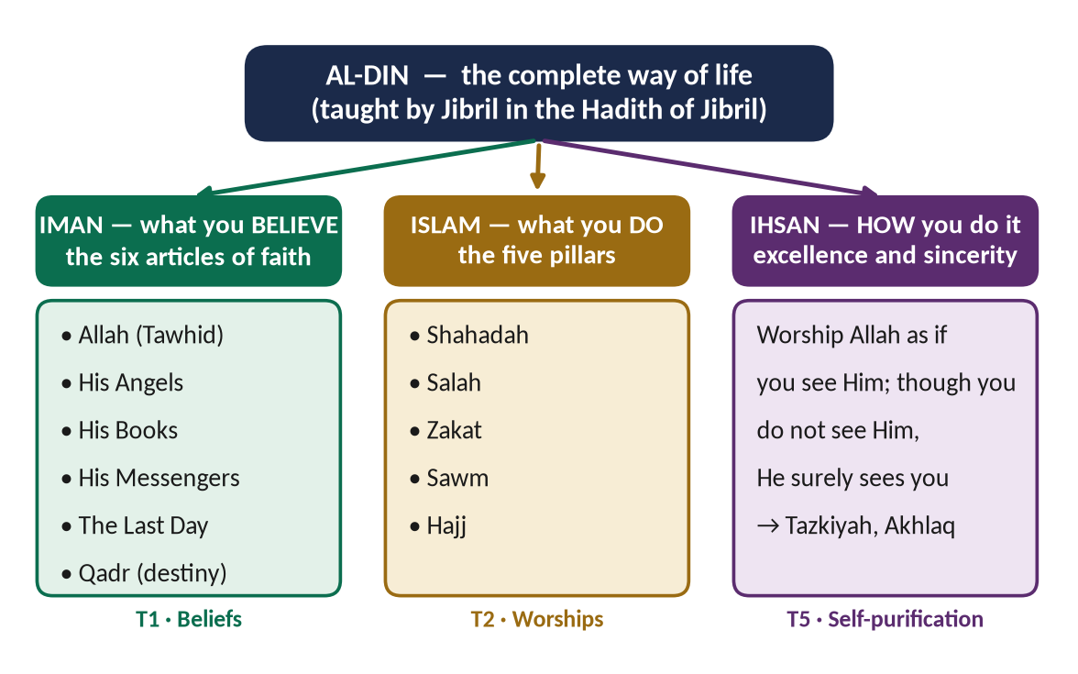
Figure 2 · Al-Din in one picture: the three levels taught in the Hadith of Jibril, and the topics of these notes that carry them.
✦ HADITH
الْإِسْلَامُ أَنْ تَشْهَدَ أَنْ لَا إِلَهَ إِلَّا اللَّهُ وَأَنَّ مُحَمَّدًا رَسُولُ اللَّهِ، وَتُقِيمَ الصَّلَاةَ، وَتُؤْتِيَ الزَّكَاةَ، وَتَصُومَ رَمَضَانَ، وَتَحُجَّ الْبَيْتَ إِنِ اسْتَطَعْتَ إِلَيْهِ سَبِيلًا
“Islam is that you testify that there is no god but Allah and that Muhammad is the Messenger of Allah, that you establish prayer, pay Zakat, fast in Ramadan, and perform Hajj to the House if you are able to find a way to it.” (Muslim)
➜ The five pillars — the practical floor of the religion (T2).

✦ HADITH
أَنْ تُؤْمِنَ بِاللَّهِ وَمَلَائِكَتِهِ وَكُتُبِهِ وَرُسُلِهِ وَالْيَوْمِ الْآخِرِ، وَتُؤْمِنَ بِالْقَدَرِ خَيْرِهِ وَشَرِّهِ
“[Iman is] that you believe in Allah, His angels, His Books, His Messengers and the Last Day, and that you believe in destiny, its good and its bad.” (Muslim)
➜ The six articles of faith — the foundation on which the whole building stands (T1).

✦ HADITH
أَنْ تَعْبُدَ اللَّهَ كَأَنَّكَ تَرَاهُ، فَإِنْ لَمْ تَكُنْ تَرَاهُ فَإِنَّهُ يَرَاكَ
“[Ihsan is] that you worship Allah as though you see Him; and though you do not see Him, He surely sees you.” (Muslim)
➜ Ihsan — the inner excellence that becomes self-purification (Tazkiyah) and noble character (T5, and asked in 2018).

REMEMBER · THE ONE-LINE DEFINITION OF ISLAM
Islam is complete submission to the will of Allah, as revealed in the Quran and shown in the life of the Prophet ﷺ — a Din that joins belief, worship, morality, law and society into one system.
Literal meaning: from the root s-l-m — submission, and also peace (salam) and safety.

0.3 The two sources — and how to quote them

The Quran
- The Word of Allah, revealed to the Prophet ﷺ through the angel Jibril over about 23 years (610–632 CE): about thirteen years in Makkah and ten in Madinah.
- 114 surahs (chapters) and about 6,236 ayat (verses) in the common count; the longest surah is Al-Baqarah, the shortest Al-Kawthar.
- Compiled into one written copy under Hazrat Abu Bakr (RA) by a committee led by Hazrat Zaid bin Thabit (RA); standard copies were sent to the provinces under Hazrat Uthman (RA).
- Makki surahs build belief (Tawhid, Risalat, Akhirah); Madani surahs build society (law, family, economy, state, war and peace). This one fact helps you pick verses: beliefs → Makki; systems → Madani.

The Sunnah and the Hadith
- Sunnah is the way of the Prophet ﷺ — his sayings (qawli), his actions (fi'li) and his silent approvals (taqriri). Hadith is the report that carries it.
- The six major collections, the Sihah Sittah: Sahih Al-Bukhari, Sahih Muslim, Sunan Abu Dawud, Jami' Al-Tirmidhi, Sunan Al-Nasa'i and Sunan Ibn Majah. Bukhari and Muslim together are called the Sahihayn.
- Grades: Sahih (sound), Hasan (good) and Da'if (weak). A sound hadith needs five conditions: a connected chain, upright narrators, precise narrators, no hidden defect and no contradiction of stronger evidence (asked as an MCQ in 2026).

How the references are written in these notes — and in your paper
Source | Write it like this | Why
A Quranic verse | (Al-Hujurat, Quran) | The surah's name is enough in an exam; examiners do not deduct for a missing verse number, but they do for a wrong one.
A hadith | (Al-Bukhari) · (Muslim) · (Al-Bukhari and Muslim) · (Abu Dawud) · (Al-Tirmidhi) | The collection shows you know where it comes from.
A Companion's saying | — Hazrat Umar (RA) | The name is the reference.
A scholar | — Imam Ghazali, Ihya Ulum al-Din | Name, and the book if you know it.

TRAP · NEVER WRITE A VERSE OR HADITH YOU ARE NOT SURE OF
A misquoted verse is worse than no verse. If you are unsure of the Arabic, write the English meaning in quotation marks with the surah's name. If you are unsure of the English, paraphrase it: 'The Quran declares that the most honoured of people in the sight of Allah is the most righteous (Al-Hujurat, Quran).' That still earns the evidence mark.
Popular sayings that are weak or not hadith at all — do not attribute them to the Prophet ﷺ: 'Seek knowledge even if you have to go to China' (weak); 'The ink of the scholar is holier than the blood of the martyr' (weak); 'Differences in my Ummah are a mercy' (no reliable chain); 'Love of the homeland is part of faith' (not a hadith). These notes flag such sayings wherever they tempt you.

0.4 How Islam makes law — the sources in one figure
Several questions (Sunnah 2015, Ijma 2017 and 2023, Ijtihad 2018 and 2022) and the whole of Topic 9 rest on one idea: Islamic law flows downwards from revelation. The Quran and the Sunnah are revealed; Ijma, Qiyas and Ijtihad are the methods by which qualified scholars apply revelation to new situations.
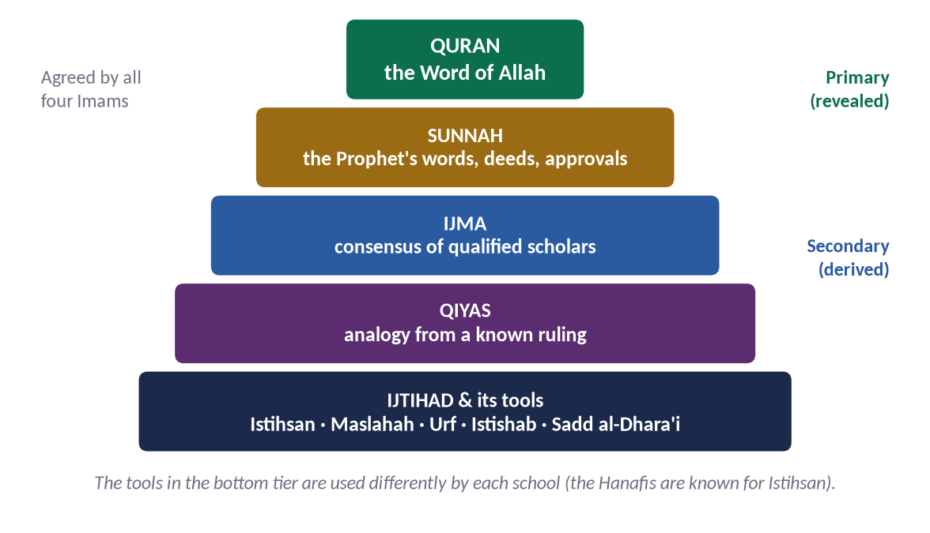
Figure 3 · The sources of Islamic law. The top two are revealed and binding on all; the lower tiers are derived by qualified scholars.
✦ QURAN
﴿يَـٰٓأَيُّهَا ٱلَّذِينَ ءَامَنُوٓاْ أَطِيعُواْ ٱللَّهَ وَأَطِيعُواْ ٱلرَّسُولَ وَأُوْلِي ٱلۡأَمۡرِ مِنكُمۡۖ فَإِن تَنَٰزَعۡتُمۡ فِي شَيۡءٖ فَرُدُّوهُ إِلَى ٱللَّهِ وَٱلرَّسُولِ إِن كُنتُمۡ تُؤۡمِنُونَ بِٱللَّهِ وَٱلۡيَوۡمِ ٱلۡأٓخِرِۚ ذَٰلِكَ خَيۡرٞ وَأَحۡسَنُ تَأۡوِيلًا﴾
“O you who have believed, obey Allah and obey the Messenger and those in authority among you. And if you disagree over anything, refer it to Allah and the Messenger, if you should believe in Allah and the Last Day. That is the best [way] and best in result.” (An-Nisa, Quran)
➜ The ladder of authority in one verse: obey Allah (the Quran), obey the Messenger (the Sunnah), and those in authority; and refer disputes back to Allah and the Messenger — the root of Ijtihad and the principle behind Article 227 of the Constitution of Pakistan.

0.5 The words you must know before anything else
These words appear on almost every page of every topic. Learn the English meaning of each; learn the Arabic spelling of the starred ones (★), because examiners notice a correctly written key term. Each Knowledge Base repeats and deepens them.

Belief (T1)
Term | Arabic | Meaning
Din ★ | دِين | A complete way of life: belief, worship, morality, law and social order together; wider than 'religion'.
Islam ★ | إِسْلَام | Submission to Allah; from s-l-m — also peace and safety.
Iman ★ | إِيمَان | Faith: belief in the heart, declaration by the tongue, confirmation by deeds.
Ihsan ★ | إِحْسَان | Excellence: worshipping Allah as though you see Him.
Tawhid ★ | تَوْحِيد | The Oneness of Allah — in lordship, in worship, and in names and attributes.
Shirk | شِرْك | Associating partners with Allah; the Quran calls it the greatest injustice (Luqman).
Risalah / Nubuwwah ★ | رِسَالَة / نُبُوَّة | Messengership / Prophethood: Allah's guidance sent through chosen human beings.
Khatm al-Nubuwwah ★ | خَتْمُ النُّبُوَّة | The Finality of Prophethood: Muhammad ﷺ is the last Prophet (Al-Ahzab).
Akhirah ★ | آخِرَة | The Hereafter: resurrection, judgement, reward and punishment.
Wahi ★ | وَحْي | Revelation: Allah's communication to His Prophets; literally a swift, hidden message.
Qadr | قَدَر | Divine decree: Allah's knowledge and plan of all things.

Worship (T2)
Term | Arabic | Meaning
Ibadah ★ | عِبَادَة | Worship in its widest sense: every act done in obedience to Allah.
Salah | صَلَاة | The five daily prayers; literally supplication and connection.
Zakat ★ | زَكَاة | The obligatory annual alms (2.5% on savings above nisab); literally purification and growth.
Sawm | صَوْم | Fasting; literally abstaining. Its purpose: taqwa (Al-Baqarah).
Hajj | حَجّ | Pilgrimage to Makkah; literally 'to intend a journey'.
Taqwa ★ | تَقْوَى | God-consciousness; guarding oneself from what displeases Allah.
Fard Ayn / Fard Kifayah ★ | فَرْضُ عَيْن / فَرْضُ كِفَايَة | An individual duty on every Muslim / a collective duty that is fulfilled when enough people perform it (asked 2025).

Sirah (T3)
Term | Arabic | Meaning
Sirah ★ | سِيرَة | The life of the Prophet ﷺ; literally 'the way of travelling'.
Ghazwah / Sariyyah | غَزْوَة / سَرِيَّة | A campaign the Prophet ﷺ led himself / an expedition he sent under a commander.
Hijrah | هِجْرَة | The migration from Makkah to Madinah in 622 CE; the start of the Islamic calendar.
Mithaq | مِيثَاق | A covenant or charter — as in the Charter (Mithaq) of Madinah.
Sulh | صُلْح | A peace treaty or reconciliation — as in Sulh al-Hudaybiyyah.
Uswah Hasanah ★ | أُسْوَةٌ حَسَنَة | The excellent example (Al-Ahzab): the Prophet ﷺ as the role model.

Rights, society and civilization (T4–T5)
Term | Arabic | Meaning
Huquq Allah / Huquq al-Ibad ★ | حُقُوقُ الله / حُقُوقُ الْعِبَاد | The rights of Allah / the rights of people. Allah may forgive the first; the second must be returned to people.
Karamah | كَرَامَة | Human dignity — 'We have honoured the children of Adam' (Al-Isra).
Adl ★ | عَدْل | Justice: giving everyone their due.
Mahr / Nafaqah / Mirath | مَهْر / نَفَقَة / مِيرَاث | The bride's due gift / maintenance / inheritance — the three financial rights of women.
Tazkiyah ★ | تَزْكِيَة | Self-purification: cleansing the soul of vices and growing its virtues.
Akhlaq | أَخْلَاق | Morals and character.
Tahdhib / Thaqafah | تَهْذِيب / ثَقَافَة | Civilization (refinement) / culture (the way a people live and think).
Tasawwuf | تَصَوُّف | Sufism: the discipline of Ihsan and purification of the heart (asked 2021).

The world and extremism (T6–T7)
Term | Arabic | Meaning
Ummah ★ | أُمَّة | The worldwide community of Muslims, one body across nations.
Wasatiyyah ★ | وَسَطِيَّة | Moderation — 'We made you a middle nation' (Al-Baqarah).
Ghuluw | غُلُوّ | Extremism: going beyond limits in religion; forbidden by Quran and Sunnah.
Jihad ★ | جِهَاد | Striving in the way of Allah: with the self, the tongue, the pen, wealth and — under a lawful state — arms.
Fasad | فَسَاد | Corruption and disorder on earth; the opposite of Jihad (asked 2015).
Takfir | تَكْفِير | Declaring a Muslim an unbeliever — the root of much extremism; condemned by the scholars.
Mu'ahid | مُعَاهَد | A non-Muslim under covenant with the Muslim state; his life and property are protected.

Governance and law (T8–T9)
Term | Arabic | Meaning
Shariah ★ | شَرِيعَة | The divine law; literally 'the path to the water'.
Fiqh | فِقْه | Human understanding of the Shariah; Islamic jurisprudence.
Ijma ★ | إِجْمَاع | Consensus of the qualified scholars of an age on a ruling.
Qiyas | قِيَاس | Analogy: extending a ruling to a new case with the same effective cause.
Ijtihad ★ | اِجْتِهَاد | Utmost effort by a qualified jurist to derive a ruling; Iqbal's 'principle of movement'.
Maqasid al-Shariah ★ | مَقَاصِدُ الشَّرِيعَة | The five aims of the Shariah: protecting religion, life, intellect, lineage and property (Imam Ghazali).
Khilafah | خِلَافَة | Vicegerency; the Islamic state under the Rightly-Guided Caliphs.
Shura ★ | شُورَى | Consultation — a Quranic duty of rulers and a quality of believers (Al-Shura).
Bay'ah | بَيْعَة | The oath of allegiance by which the people accept a ruler.
Amanah ★ | أَمَانَة | Trust — public office is a trust (An-Nisa).
Hisbah ★ | حِسْبَة | The institution of accountability and public morality; its officer is the Muhtasib.
Bayt al-Mal | بَيْتُ الْمَال | The public treasury.
Riba ★ | رِبًا | Interest/usury; prohibited (Al-Baqarah). Pakistan: to be eliminated by 1 January 2028.

0.6 The whole syllabus in twenty minutes
Read these nine short stories once, in order. They are the whole paper in miniature; each becomes a topic of these notes.

Topic 1 · Introduction to Islam and the Islamic Beliefs
Islam is not one department of life called 'religion'; it is Din — a complete way of life. It rests on belief: Tawhid (Allah is One), Risalat (He guides mankind through Prophets, ending with Muhammad ﷺ — the Finality of Prophethood), and Akhirah (every soul will answer for its deeds). Human reason and experience are valuable but limited; Wahi (revelation) is the only certain guide. These beliefs change the individual (dignity, courage, responsibility) and society (equality, justice, unity). The examiner asks this topic almost every year.

Topic 2 · Islamic Worships (Ibadat) and Their Impact
Belief becomes practice through the five pillars. Salah builds discipline and brotherhood five times a day; Zakat purifies wealth and circulates it to eight categories of the needy; Sawm trains taqwa; Hajj gathers the Ummah in equality. Every act of worship has a spiritual, moral and social impact — the three words the examiner uses again and again. Some duties are individual (Fard Ayn), others collective (Fard Kifayah): medicine, defence, research, even clean government.

Topic 3 · The Sirah of the Prophet ﷺ as Role Model
The Prophet ﷺ is the Uswah Hasanah — the perfect model. As an individual: truthful (al-Amin), humble, merciful. As an educator: he turned an unlettered people into teachers of the world. As a diplomat: letters to kings, treaties, delegations. As a military strategist: Badr, Uhud, the Trench, Makkah — won with the fewest lives in history. As a peace maker: the Charter of Madinah, Hudaybiyyah, the general pardon at Makkah. This is the most-asked topic of the paper.

Topic 4 · Human Rights, Human Dignity, Women and the Family
Fourteen centuries before the UDHR, Islam declared that all human beings are honoured and equal, and the Farewell Sermon proclaimed the sanctity of life, property and honour. Women were given the right to life, education, property, mahr, maintenance, inheritance, consent in marriage and respect as mothers, wives and daughters. The family is the first school of society. The examiner asks this topic almost every year — often against feminism or the UDHR.

Topic 5 · Islamic Civilization and Culture
Civilization is the outward form of a people's inner beliefs. Islamic civilization stands on eight pillars named in the syllabus: Tawhid, self-purification, dignity of man, equality, social justice, moral values, tolerance and the rule of law. Its heart is Tazkiyah — the purification of the soul — which the examiner has asked three times, and Sufism, which carried Islam to South Asia.

Topic 6 · Islam and the World: the West, the Ummah and Pakistan
Islamic civilization lit the West — Cordoba, Baghdad, algebra, optics, medicine — and the modern West now shapes Muslim societies. The Ummah faces contemporary challenges: disunity, poverty, illiteracy, dependence, Islamophobia and the oppression of Muslims in Kashmir, Palestine and elsewhere. Pakistan itself was built on the Two-Nation Theory; the task now is to rebuild Pakistani society on Islamic teachings.

Topic 7 · Extremism, Terrorism, Sectarianism and Jihad
Extremism (ghuluw) is a betrayal of Islam, which is the religion of the middle way. Terrorism, sectarianism and takfir have political, economic, educational and foreign causes. Jihad is a noble, disciplined striving — with the self, the pen and, only under a lawful state and strict rules, the sword; it is the opposite of Fasad. Pakistan's answer is the Paigham-e-Pakistan consensus. Asked six times in twelve years.

Topic 8 · Public Administration and Governance in Islam
In Islam, power is an amanah (trust) and government is service. The Quran lays down justice, consultation (Shura), merit and accountability. The Rightly-Guided Caliphs were chosen by consultation and allegiance, lived like ordinary citizens, and answered to the people; Hazrat Umar's and Hazrat Ali's letters to their governors are still manuals of administration. Civil servants are trustees; Hisbah keeps them honest.

Topic 9 · The Islamic Code of Life: Sources of Law and the Islamic Systems
Islam is a complete code of life: a social system (family, rights, morality), a political system (sovereignty of Allah, Shura, justice), an economic system (Zakat, no riba, no hoarding, fair trade), a judicial system (independent judges, equality before law) and an administrative system (merit, trust, accountability). The law comes from the Quran and Sunnah, and grows through Ijma, Qiyas and Ijtihad — which is how Islam answers new questions.

0.7 The time-line behind the paper
Islamic Studies is not a history paper, but its evidence comes from history: the Prophet's life, the Rightly-Guided Caliphs, the great age of Muslim learning, and Pakistan. Place every example on this line.
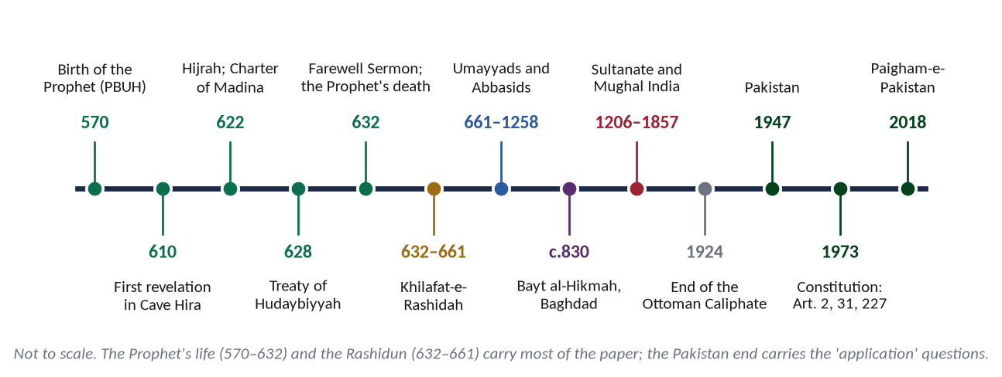
Figure 4 · The time-line behind the paper: the events and eras that supply most of the examples in these notes.
Date | Event | Used in
610 | First revelation in the Cave of Hira (Al-Alaq) | T1 (Wahi), T3 (educator)
622 | Hijrah; brotherhood (Mu'akhat); Charter of Madinah | T3, T4, T6, T8
624 · 2 AH | Battle of Badr: 313 against about 1,000 | T3 (strategist)
625 · 3 AH | Battle of Uhud: the lesson of discipline | T3
627 · 5 AH | Battle of the Trench (Ahzab): the trench strategy | T3
628 · 6 AH | Treaty of Hudaybiyyah — the 'clear victory'; letters to kings follow | T3 (peace, diplomat)
630 · 8 AH | Conquest of Makkah; the general amnesty | T3, T5 (tolerance)
632 · 10 AH | The Farewell Sermon; the Prophet's death | T4 (human rights)
632–661 | Khilafat-e-Rashidah: Abu Bakr, Umar, Uthman, Ali (RA) | T8, T9
c. 750–1258 | The Abbasid age; Bayt al-Hikmah; the four Imams and the six hadith collections | T5, T6, T9
1947 | Pakistan, on the Two-Nation Theory | T6
1949 · 1973 | Objectives Resolution; Constitution (Articles 2, 2A, 31, 38, 227) | T6, T8, T9
2018 | Paigham-e-Pakistan: national consensus against extremism | T7

0.8 Names and honorifics
Use the honorifics consistently. They are a mark of respect and examiners notice them.
For | Write | Meaning
The Prophet Muhammad | ﷺ or (PBUH) | Sallallahu alaihi wa sallam — may Allah bless him and grant him peace.
Other Prophets and angels | (AS) | Alaihis salam — peace be upon him.
A Companion | (RA) | Radiyallahu anhu / anha — may Allah be pleased with him / her.
A great scholar of the past | (RH) | Rahimahullah — may Allah have mercy on him.
Allah | Allah Almighty · (SWT) | Subhanahu wa ta'ala — Glorified and Exalted is He.

0.9 Six habits of mind for an Islamic Studies paper
1. Answer the question, not the topic. 'Impact on the individual and society' needs two headed sections, not an essay on Tawhid.
2. Prove, don't preach. Every claim needs evidence: a verse, a hadith, an example from the Sirah or the Caliphs, a scholar.
3. Think in systems. Islam is Din: every belief has a social result, every worship a moral result, every law a purpose (maqasid).
4. Bring it to today. The examiner is a Pakistani officer of the state. Link every answer to a present problem — and where natural, to Pakistan.
5. Be balanced. Admit the problem honestly (Muslims deny daughters their inheritance; extremists misuse Jihad), then answer it from the sources.
6. Show it. A figure — a flowchart, a table, a cycle — shows understanding at a glance and breaks a wall of text.

Part One — The Paper Itself

1.1 Where Islamic Studies sits in CSS
The CSS written examination has six compulsory papers of 100 marks each and optional papers worth 600 marks. Islamic Studies is one of the six compulsory papers. Non-Muslim candidates take Comparative Study of Major Religions in its place.
Compulsory paper | Marks | Why it matters here
English Essay | 100 | The biggest killer. Your Islamiat answers train the same skill: an argued, headed, evidenced essay.
English (Precis and Composition) | 100 | Second biggest killer.
General Science and Ability | 100
Current Affairs | 100 | Shares material with T6 and T7 (Muslim world, extremism, Islamophobia).
Pakistan Affairs | 100 | Shares material with T6 (Two-Nation Theory, Objectives Resolution, Constitution).
Islamic Studies (or Comparative Study of Major Religions) | 100 | Pass mark 40. Often the third-largest cause of failure.

- Pass mark: at least 40 in each compulsory paper (and 33 in each optional); the whole written part also needs an aggregate of 50%. One failed compulsory paper fails the whole attempt — however well you did elsewhere.
- Language: the paper is printed in English and Urdu. FPSC has allowed Islamic Studies to be answered in English or Urdu; confirm the instruction in the notice of your year. These notes are written in English.
- Why it is failed: not for lack of faith, but for answers that are general (a sermon), unproved (no verse, no hadith, or wrong ones), unstructured (no headings) and irrelevant (the question's words ignored). Part Five of this document is the cure.
EXAMINER'S EYE · THE PAPER EVERYONE THINKS IS EASY
Because every candidate studied Islamiat at school, most prepare it last and least. The examiner therefore reads hundreds of near-identical answers — the same five points, no headings, no references. An answer that is simply organised and properly evidenced stands out at once, and that is the whole strategy of these notes.

1.2 The syllabus, word for word
The syllabus has seven heads. Here it is exactly as FPSC prints it, with the topic of these notes that carries each line.
Syllabus head and line (FPSC wording) | Topic
I. Introduction to Islam
• Concept of Islam | T1
• Importance of Din in Human Life | T1
• Difference between Din and Religion | T1
• Distinctive Aspects of Islam | T1
• Islamic Beliefs & its Impact on Individual & Society and the Fundamental of Islam | T1
• Islamic Worships: Spiritual, Moral and Social Impact | T2
II. Study of Sirah of the Prophet Muhammad (PBUH) as Role Model for:
• Individual | T3
• Diplomat | T3
• Educator | T3
• Military Strategist | T3
• Peace Maker | T3
III. Human Rights & Status of Woman in Islam
• Human Rights and Status of Woman in Islam | T4
• Dignity of Men and Women | T4
IV. Islamic Civilization and Culture
• Meanings and the Vital Elements | T5
• Role of Civilization in Development of Human Personality and Community | T5
• Characteristics of Islamic Civilization (Tawhid, Self-purification, Dignity of Man, Equality, Social Justice, Moral Values, Tolerance, Rule of Law) | T5
V. Islam and the World
• Impact of Islamic Civilization on the West and Vice Versa | T6
• The Role of Islam in the Modern World | T6
• Muslim World and the Contemporary Challenges | T6
• Rise of Extremism | T7
VI. Public Administration and Governance in Islam
• Concept of Public Administration in Islam | T8
• Quranic Guidance on Good Governance | T8
• Concept of Governance and its Applications in the light of Qur'an, Sunnah and Fiqh | T8
• Governance Structure in Islam (Shura, Legislation, Sources of Islamic Law) | T8 · T9
• Governance under Pious Khilafat | T8
• Particular letters of Hazrat Umar (R.A) and Hazrat Ali (R.A) to different Authority | T8
• Responsibilities of Civil Servants | T8
• System of Accountability (Hisbah) in Islam | T8
VII. Islamic Code of Life
• Salient Features of Islamic System: Social System, Political System, Economic System, Judicial System, Administrative System | T9
• Procedure of Ijma and Ijtihad | T9

NOTE · THE URDU SYLLABUS
FPSC prints the same syllabus in Urdu (Nisab: Mutala-e-Islam / Ma'arif-e-Islami). Two Urdu phrases make the intention clearer than the English: the Prophet ﷺ is studied as Mu'allim-e-Insaniyat (teacher of humanity) and Paighambar-e-Aman (Prophet of peace); and the civilization head speaks of the role of civilization in building (ta'mir) society and the human personality.

1.3 The reading list — which books actually help
FPSC attaches a reading list of seventeen required and five recommended books. You do not need to read them all; you need to know what each is good for, so that a quotation or an idea can be traced to a respected source. The list is also a guide to the examiner's mind: it tells you which authors the paper-setters regard as standard.
No. | Title | Author | Topics | Verdict
1 | Introduction to Islam | Dr Muhammad Hamidullah | T1, T2, T8, T9 | ★★★ The best single book: short, balanced, scholarly.
2 | Islam: Its Meaning and Message | Khurshid Ahmad (ed.) | T1, T5, T9 | ★★★ Essays on Din, economics, society.
3 | Islam: The Misunderstood Religion | Muhammad Qutb | T4, T6 | ★★ Answers Western objections (women, slavery, capitalism).
4 | Islam at the Crossroads | Muhammad Asad | T6 | ★★★ Islam and the West — asked 2015, 2025, 2026.
5 | Islam and the Economic Challenge | M. Umer Chapra | T9 | ★★★ Islamic economics; wealth concentration (2025).
6 | A Brief Survey of Muslim Science and Culture | M. Abdur Rahman | T5, T6 | ★★ Muslim contributions to science; MCQ facts.
7 / 20 | Administrative Development: An Islamic Perspective | Muhammad Al-Buraey | T8 | ★★★ Public administration, civil servants.
8 | Quranic Sciences | Afzalur Rahman | T1, T9 | ★★ Wahi, compilation of the Quran; MCQ facts.
9 | Islamization of Pakistan | Zafar Iqbal | T6, T9 | ★★ Pakistan's Islamic provisions and institutions.
10 / 17 / 18 | Islamic Law and Constitution · Khilafat-o-Mulukiat · Towards Understanding Islam | Abul A'la Mawdudi | T1, T8, T9 | ★★ On the list; use for the concepts they explain (Din, Khilafat, constitution), not for contested positions.
11 | Insan-e-Kamil | Dr Khalid Alvi | T3 | ★★★ The Prophet ﷺ as the perfect model — role-by-role.
12 | Islami Tehzeeb kay Chund Darakhshan Pehloo | Mustafa Sibai | T5 | ★★★ Characteristics of Islamic civilization.
13 | Islam aur Tehzeeb-e-Maghrib ki Kashmakash | Dr Muhammad Amin | T6 | ★★ Islam and Western civilization.
14 | Aurat Maghrib aur Islam | Serwat Jamal Asmai | T4 | ★★ Women: the Western and Islamic models compared.
15 | Seerat-un-Nabi, Vol. I | Shibli Nomani | T3 | ★★★ The classic Sirah; Syed Sulaiman Nadvi completed it.
16 | Islam and Secular Mind | Tarik Jan (ed.) | T6 | ★ Islam and secular thought.
19 | Ideals and Realities of Islam | Seyyed Hossein Nasr | T1, T5 | ★★ Spiritual dimension; Sufism.
21 | Arab Administration | S. A. Q. Husaini (listed as Hussain Shah) | T8 | ★★ Administration under the Caliphs.
22 | The Islamic Republic: Politics, Law and Economy | Dr S. Farooq Hassan | T8, T9 | ★ The Islamic state in modern form.

Beyond the list — the sources these notes also draw on
- Sirah: Syed Sulaiman Nadvi, Khutbat-e-Madras (the eight lectures on the Sirah — an MCQ in 2026); Dr Hamidullah, The Battlefields of the Prophet Muhammad and The First Written Constitution in the World; Martin Lings, Muhammad: His Life Based on the Earliest Sources; Safi-ur-Rahman Mubarakpuri, Al-Raheeq al-Makhtum.
- Thought and law: Allama Iqbal, The Reconstruction of Religious Thought in Islam; Shah Waliullah, Hujjat Allah al-Baligha; Imam Ghazali, Ihya Ulum al-Din and Al-Mustasfa; al-Mawardi, Al-Ahkam al-Sultaniyyah; Imam Abu Yusuf, Kitab al-Kharaj; Ibn Khaldun, Muqaddimah; Dr Mahmood Ahmad Ghazi, Muhazirat series (on Quran, Hadith, Fiqh, Sirah and Shariah).
- Economy: Mufti Muhammad Taqi Usmani, An Introduction to Islamic Finance; the Federal Shariat Court's riba judgment of 2022.
- The West and the modern world: W. Montgomery Watt, Karen Armstrong, John Esposito, Edward Said (Orientalism), Samuel Huntington (The Clash of Civilizations, an MCQ in 2026).
- Pakistan: the Constitution of 1973, the Objectives Resolution (1949), the reports of the Council of Islamic Ideology, Paigham-e-Pakistan (2018).

1.4 How the paper is built

Part I — the objective questions (MCQs)
- 20 MCQs, 1 mark each, 20 marks. Printed as Q. No. 1, attempted on the separate MCQ answer sheet, collected after 30 minutes.
- Attempt every item: an unanswered MCQ is a certain zero.
- The MCQs are overwhelmingly factual — Sirah, Quran, Companions — and quite unlike the descriptive part. They need a separate drill (section 3.8 and the One-Liner Bank).

Part II — the descriptive questions
- Seven questions (Q. 2 to Q. 8); attempt any four; 20 marks each; 80 marks. Two and a half hours.
- The last question (Q. 8) is sometimes two short notes of 10 marks each (2021, 2023, 2024).
- Instructions printed on the paper each year: attempt only four questions; all parts of a question at one place; write the question number as in the paper; no page or space left blank between answers; extra attempts are not marked.

The 2015 exception
The 2015 paper followed the older pattern: eight descriptive questions of 16 marks each, of which five were attempted. From 2016 onwards the paper has been seven questions of 20 marks, attempt four. These notes are written for the present pattern; the 2015 questions are included in every count because the examiner repeats their themes.

1.5 The marks and the minutes
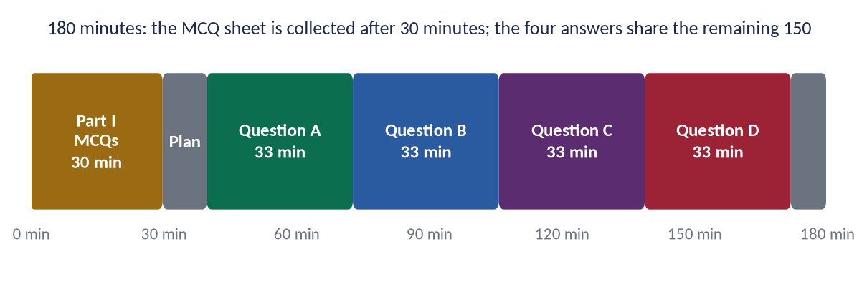
Figure 5 · The three hours of the Islamic Studies paper.
Stage | Minutes | What you do
Part I (MCQs) | 30 | Answer all 20. Do not return to them — the sheet is taken away.
Choose and plan | 10 | Read all seven questions; tick four; for each, draw the answer map (mind map) in the margin or on the first page.
Each answer (×4) | 33 | About 1,300–1,800 words of your handwriting: 8–12 headings, 6–10 pieces of evidence, one or two figures.
Final check | 8 | Numbering, headings underlined, references correct, no blank pages.

TRAP · THE FIFTH ANSWER THAT NEVER HAPPENS
Candidates spend fifty minutes on their favourite question and write the fourth in fifteen. Four equal answers of 13/20 (52) beat three brilliant ones and a stub (16 + 16 + 16 + 4 = 52) — and are far safer. Watch the clock at 73, 106, 139 and 172 minutes.

1.6 Why candidates fail — and how to be in the other group
The failing script | The passing script | The high-scoring script
Starts with a paragraph of praise; no definition | Defines the key term | Opens with a verse, defines the term literally and technically, states a thesis
One long essay, no headings | Headings, but generic (Introduction, Importance, Conclusion) | Headings taken from the question's own words, with numbered sub-headings to four levels
No references, or a wrong verse | Two or three verses, some without references | Evidence inside every heading: verse → hadith → Companion → scholar → example
Answers half the question | Answers every part, unevenly | Answers every part in proportion, and signals each part clearly
No figure | One table | An answer map + a flowchart/table/cycle that carries an argument
Nothing about today | A line on 'modern times' | A contemporary/Pakistan section: the problem, the data, the Constitution, the solution
Ends mid-sentence | Short conclusion | Conclusion that answers the question, recommends, and closes with a verse or hadith

1.7 The twelve papers at a glance
Each row is one year; each cell shows the topic of the question and its family. Read across a year to feel the examiner's balance; read down a column to see that no year leaves out Topics 3, 4 and 7 for long.
Year | The descriptive questions (topic: family)
2015 | Q2 T6: Ummah & challenges  Q3 T7: Jihad  Q4 T1: Prophethood & Finality  Q5 T2: Zakat  Q6 T9: Sources: Sunnah, Ijma, Ijtihad  Q7 T1: Wahi  Q8 T4: Family  Q9 T6: Islam & the West
2016 | Q2 T5: Civilization: meaning & characteristics  Q3 T1: Din & Religion  Q4 T3: Military strategist  Q5 T2: Salah  Q6 T8: Civil servants & public administration  Q7 T8: Khilafat & political system  Q8 T6: Ummah & challenges
2017 | Q2 T2: Zakat  Q3 T4: Women's rights  Q4 T8: Khilafat & political system  Q5 T3: Peace maker  Q6 T5: Self-purification & Sufism  Q7 T7: Extremism & terrorism in Pakistan  Q8 T9: Sources: Sunnah, Ijma, Ijtihad
2018 | Q2 T9: Sources: Sunnah, Ijma, Ijtihad  Q3 T5: Self-purification & Sufism  Q4 T7: Extremism & terrorism in Pakistan  Q5 T8: Civil servants & public administration  Q6 T2: Zakat  Q7 T5: Civilization: meaning & characteristics  Q8 T3: Peace maker
2019 | Q2 T1: Tawhid  Q3 T3: Military strategist  Q4 T4: Women's rights  Q5 T5: Civilization: meaning & characteristics  Q6 T2: Hajj  Q7 T7: Extremism & terrorism in Pakistan  Q8 T8: Khilafat & political system
2020 | Q2 T3: Character: tolerance & morals  Q3 T8: Khilafat & political system  Q4 T4: Human rights & dignity  Q5 T7: Jihad  Q6 T3: Charter of Madina  Q7 T4: Human rights & dignity  Q8 T9: Economic system
2021 | Q2 T1: Akhirah  Q3 T4: Women's rights  Q4 T6: Co-existence & tolerance  Q5 T6: Islamophobia  Q6 T8: Accountability (Hisbah)  Q7 T5: Self-purification & Sufism  Q8 T3: Peace maker
2022 | Q2 T4: Women's rights  Q3 T9: Economic system  Q4 T9: Sources: Sunnah, Ijma, Ijtihad  Q5 T1: Prophethood & Finality  Q6 T3: Peace maker  Q7 T6: Pakistan & Islam  Q8 T1: Din & Religion
2023 | Q2 T1: Akhirah  Q3 T3: Military strategist  Q4 T4: Women's rights  Q5 T9: Sources: Sunnah, Ijma, Ijtihad  Q6 T3: Charter of Madina  Q7 T7: Extremism & terrorism in Pakistan  Q8 T4: Human rights & dignity
2024 | Q2 T5: Self-purification & Sufism  Q3 T3: Military strategist  Q4 T1: Prophethood & Finality  Q5 T4: Human rights & dignity  Q6 T8: Accountability (Hisbah)  Q7 T7: Extremism & terrorism in Pakistan  Q8 —: Short notes (parts not recovered)
2025 | Q2 T3: Character: tolerance & morals  Q3 T2: Fard Kifayah  Q4 T5: Equality & social justice  Q5 T9: Economic system  Q6 T3: Peace maker  Q7 T5: Tolerance in Muslim history  Q8 T6: Islam & the West
2026 | Q2 T4: Human rights & dignity  Q3 T6: Pakistan & Islam  Q4 T6: Islam & the West  Q5 T1: Tawhid  Q6 T8: Accountability (Hisbah)  Q7 T7: Extremism & terrorism in Pakistan  Q8 T4: Family

Part Two — Nine Topics: Rebuilding the Syllabus

2.1 Why nine topics — and why these nine
The seven syllabus heads are very uneven. Head I holds six lines, including two different worlds (beliefs and worships). Head II holds five roles of the Prophet ﷺ, and is the most-asked area of the paper. Head V mixes the West, the modern world, the Ummah and extremism. Head VI holds eight lines. Head VII holds five systems and the sources of law. A topic should be one thing you can master in one to two weeks, and its weight should match the examiner's interest. Four decisions follow:
1. Head I is split in two — Beliefs (T1, asked 10 times) and Worships (T2, asked 6 times) — because a belief question and a worship question are answered in completely different ways.
2. Head V is split in two — Islam and the World (T6) and Extremism, Terrorism, Sectarianism and Jihad (T7) — because 'extremism in Pakistan' is the single most repeated family of the whole paper (six times), and Jihad (twice) belongs with it.
3. 'Sources of Islamic Law' moves from Head VI to T9, so that the Quran, Sunnah, Ijma, Qiyas and Ijtihad are taught together with 'the procedure of Ijma and Ijtihad' (Head VII). Governance (T8) keeps Shura and legislation.
4. The family goes into T4 with women and human rights, because the examiner asks about it in that frame (2015, 2026).
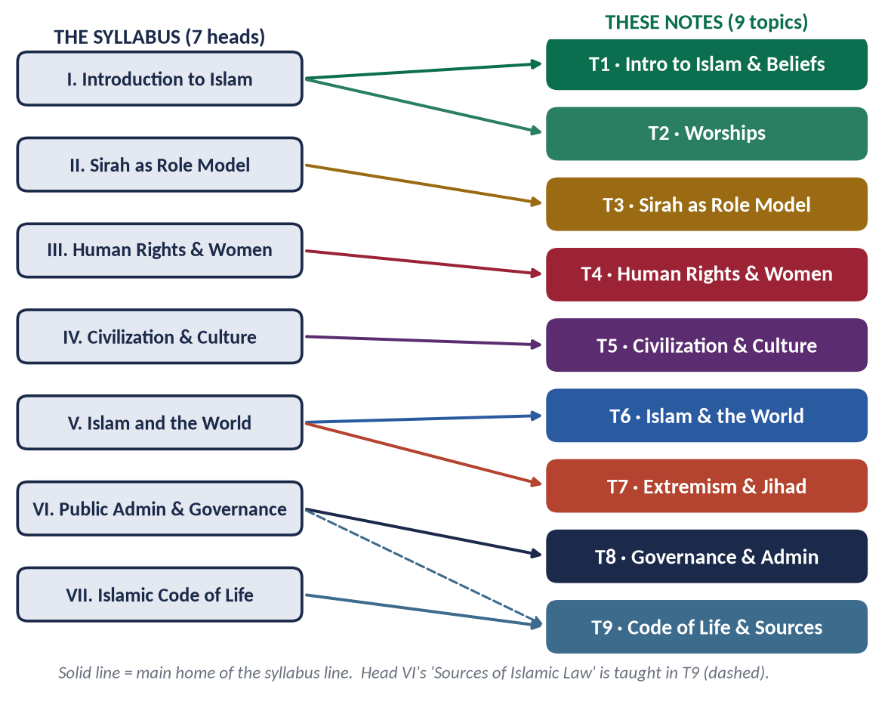
Figure 6 · From seven syllabus heads to nine topics.

2.2 From seven heads to nine topics — the full mapping
Topic | Head | Syllabus lines | What the record adds
T1 | I | Concept of Islam · Importance of Din · Din vs Religion · Distinctive aspects · Islamic beliefs and their impact · Fundamentals of Islam | + Wahi and the sources of knowledge (2015) · rational arguments for Allah (2026) · Finality of Prophethood
T2 | I | Islamic worships: spiritual, moral and social impact | + Fard Ayn and Fard Kifayah (2025) · Zakat and poverty (three times)
T3 | II | The Prophet ﷺ as Individual, Diplomat, Educator, Military Strategist, Peace Maker | + Charter of Madinah · treaties · Makarim al-Akhlaq · tolerance and forgiveness · Ghazwat for peace
T4 | III | Human rights and status of women · Dignity of men and women | + Farewell Sermon · UDHR and Cairo Declaration · feminism · inheritance · daughters · the family
T5 | IV | Meanings and vital elements · Role in personality and community · The eight characteristics | + Tazkiyah and Ihsan · Sufism · classism and equality · religious tolerance in Muslim history
T6 | V | Impact on the West and vice versa · Role of Islam in the modern world · Contemporary challenges | + Muslim Ummah and its revival · co-existence · Islamophobia · Two-Nation Theory · Pakistani society
T7 | V | Rise of extremism | + terrorism in Pakistan · sectarianism and polarisation · Jihad and Fasad · Paigham-e-Pakistan
T8 | VI | Public administration · Quranic guidance on good governance · Governance in Quran, Sunnah, Fiqh · Shura and legislation · Pious Khilafat · Letters of Umar and Ali · Civil servants · Hisbah | + election of the Caliphs and democracy · Hazrat Ali · reform of Pakistani politics · accountability in Pakistan
T9 | VI · VII | Sources of Islamic law · Social, political, economic, judicial, administrative systems · Ijma and Ijtihad | + importance of Sunnah · parliament and Ijma · Islamic economics and wealth concentration · Maqasid al-Shariah

2.3 The contemporary layer — the hot topics each topic carries
The examiner of 2024–2026 wants Islam applied to the present. Every Knowledge Base therefore ends its teaching with a chapter of Contemporary Challenges, Narratives and Hot Debates, and the Prediction Papers draw on them. This is the list the notes will cover.
Topic | Contemporary challenges, narratives and debates
T1 | Atheism and 'new atheism' among the youth · science and religion · secularism and the 'religion is private' narrative · the Finality of Prophethood and its constitutional protection (Article 260(3)) · the meaning crisis, anxiety and depression
T2 | Worship reduced to ritual · Zakat collection and trust deficit in Pakistan · poverty data · Hajj commercialisation · Fard Kifayah in the age of AI, research, climate and public health
T3 | The Prophet ﷺ in a transnational world · responding to insults against the Prophet ﷺ: the lawful, dignified Prophetic way · Sirah and leadership/management · the Prophet ﷺ as educator in the age of AI
T4 | UDHR vs Islamic human rights · feminism and women's-rights movements (answered without insult) · honour killing, denial of inheritance, forced marriage, dowry · family breakdown, divorce rates, social media and the generation gap · rights of the elderly, children and persons with disabilities
T5 | Materialism and consumerism · elite capture and classism · moral decline and corruption · Sufism and shrine-culture deviations · digital ethics · tolerance in a polarised society
T6 | Islamophobia (UN day 15 March) · clash of civilizations · Muslim world disunity · Gaza, Kashmir, Rohingya, Indian Muslims (stated factually) · OIC's weakness · brain drain · Western cultural influence and media · AI and technology dependence
T7 | Terrorism in Pakistan since 2001 · sectarianism · takfir · online radicalisation · mob violence in the name of religion · Paigham-e-Pakistan · National Action Plan · madrasa reform
T8 | Corruption and accountability (NAB) · politicisation of the civil service · governance indicators · e-governance · merit vs nepotism · Riyasat-e-Madinah as a slogan vs as a model
T9 | Elimination of riba by 1 January 2028 (26th Amendment; FSC judgment 2022) · Islamic banking · wealth inequality · Ijtihad in bioethics, AI and finance · collective Ijtihad (CII, OIC Fiqh Academy) · parliament and Ijma

HOT DEBATE · HOW TO HANDLE A SENSITIVE ISSUE
State the issue factually → give the Quranic principle → give the Prophetic practice → give the agreed scholarly position → apply it to Pakistan → recommend. Never insult a group, a sect, a movement or a country; criticise ideas, not people. This method is used for every hot debate in the Knowledge Bases.

2.4 The two documents each topic gets

The Knowledge Base (TnKB)
1. How to use this document and the contents space.
2. Part Zero — the ABC: the key terms of the topic in Arabic and English; the background you need.
3. Part One — the chapters: one chapter for every syllabus line and every past-paper family, built from the question words, four to five heading levels deep, with evidence cards inside every point and 8–15 figures.
4. Part Two — Contemporary Challenges, Narratives and Hot Debates of the topic.
5. Part Three — The examiner's record of the topic, and five likely questions (not solved; the Prediction Papers solve predicted questions).
6. Part Four — the One-Liner Bank: short facts for MCQs and quick recall.
7. Part Five — the Revision Sheet: the whole topic on a few pages.

The Question Answers (TnQA)
1. The question exactly as set, with year and number.
2. The answer map — a mind map whose every branch is one heading of the answer.
3. Decoding the question — what the command words and each limb demand.
4. The model answer — introduction with evidence; numbered headings (1), (2)… from the question's words; sub-headings (i), (ii)… and (a), (b)…; evidence inside every heading; one or two figures; the contemporary/Pakistan angle; conclusion with a verse or hadith.
5. Why this answer scores — what the examiner rewards in it.

2.5 The compiled volumes — and the Prediction Papers
When all nine topics are complete, five volumes are compiled from them (Figure 1). Two deserve a word now:
- The Evidence Bank (EB) is compiled automatically from every verse, hadith and scholarly view used in the nine KBs and QAs — arranged topic → sub-topic → heading, each with its Arabic, translation, reference and the point it proves. Because it is compiled, not re-typed, it is exactly what you have read in the topics.
- The Prediction Papers (PR) are three complete papers, set exactly as FPSC prints the Islamic Studies paper: the FPSC heading, roll-number box, time and marks, the printed instructions, Part I with 20 MCQs (options A–D) and Part II with seven questions (Q. 2 to Q. 8, attempt four, 20 marks each, one question of two short notes). Each set is followed by the MCQ key and full model answers. Together they add 21 predicted descriptive questions drawn from the blind spots, the repeat engine and the contemporary layer.

Part Three — The Record: What Has Been Asked, 2015–2026

3.1 How the record was built
- Descriptive part: 85 questions from twelve papers (2015: eight; 2016–2026: seven each). The short-note options of 2021 (Treaty of Hudaybiyyah as a pact of peace; benefits of the Battle of Khaybar) and 2023 (human rights in the Farewell Sermon; social justice in an Islamic society) were recovered and added. The two parts of the 2024 short-notes question could not be recovered from any accessible archive; it is counted as a question but left out of the topic totals (84 tagged questions).
- Objective part: 223 MCQs recovered (full sets for ten years; ten items for 2016 and thirteen for 2020).
- Each descriptive question was tagged with its topic, its family (the recurring theme it belongs to), any second topic it leaks into, and its command words.

3.2 The heat map
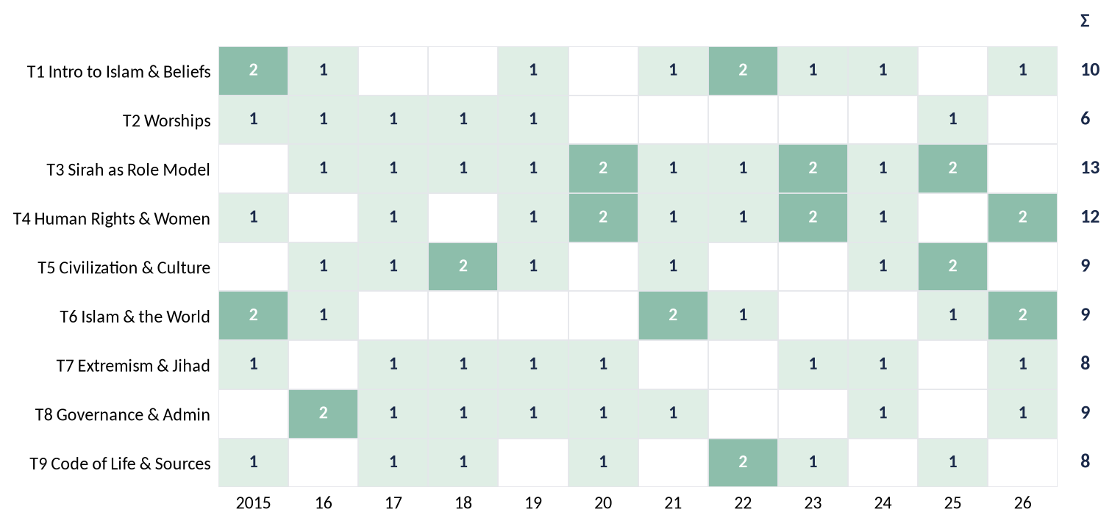
Figure 7 · The heat map: how many questions each topic received in each year, 2015–2026. Darker = more questions; Σ = total.

How to read it
- No topic is safe to leave. Every topic has been asked at least six times in twelve years; seven of the nine topics were asked in 2026 alone.
- T3 (Sirah) and T4 (Rights and women) are the pillars — asked in almost every year, often twice.
- T1 (Beliefs) comes back every year or two, usually with the words 'impact on individual and society'.
- T2 (Worships) went quiet after 2019 — and then returned in 2025 with a new angle (Fard Kifayah). A worship question is overdue; Sawm has never been asked.
- T6 and T7 have grown: the paper is moving towards the present day.

3.3 How much each topic weighs
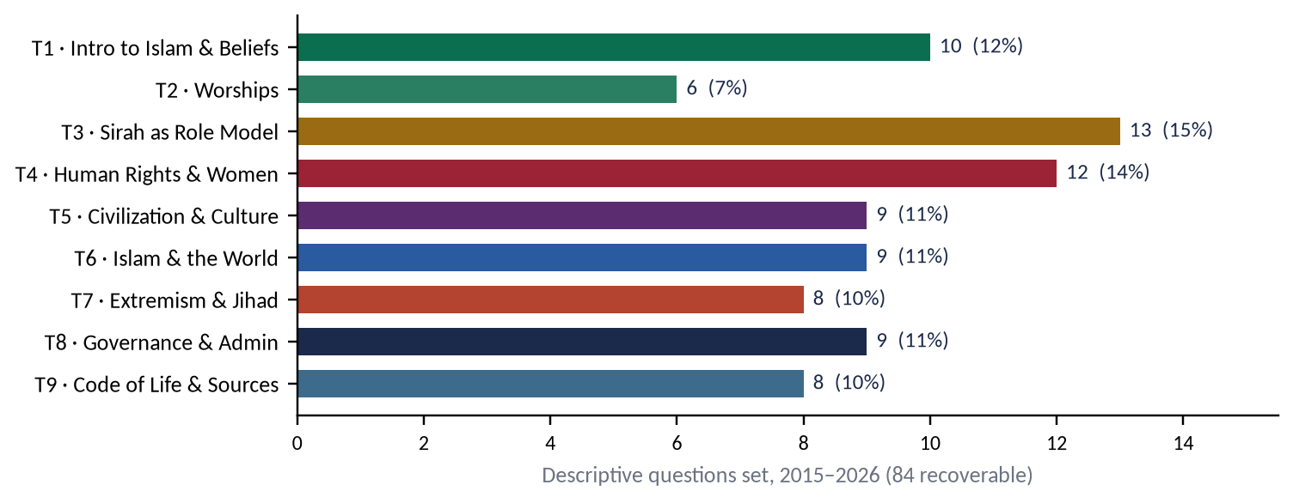
Figure 8 · The weight of each topic: descriptive questions set, 2015–2026.
Topic | Asked | Share | Verdict
T1 · Intro to Islam & Beliefs | 10 | 12% | Core. Expect one question most years.
T2 · Worships | 6 | 7% | Lower frequency; overdue; one worship with 'impacts'.
T3 · Sirah as Role Model | 13 | 15% | The heaviest. Expect one, often two.
T4 · Human Rights & Women | 12 | 14% | Heavy. Expect one, often two.
T5 · Civilization & Culture | 9 | 11% | Steady. Self-purification is a favourite.
T6 · Islam & the World | 9 | 11% | Rising. Contemporary, Pakistan-centred.
T7 · Extremism & Jihad | 8 | 10% | The most repeated family. Expect it.
T8 · Governance & Admin | 9 | 11% | Steady. Accountability three times since 2021.
T9 · Code of Life & Sources | 8 | 10% | Steady. Ijma/Ijtihad and economics alternate.

3.4 The repeat engine
The examiner does not invent a new paper every year. He or she returns to families of questions, changing the angle. Learn the families, and you have prepared for most of the next paper.
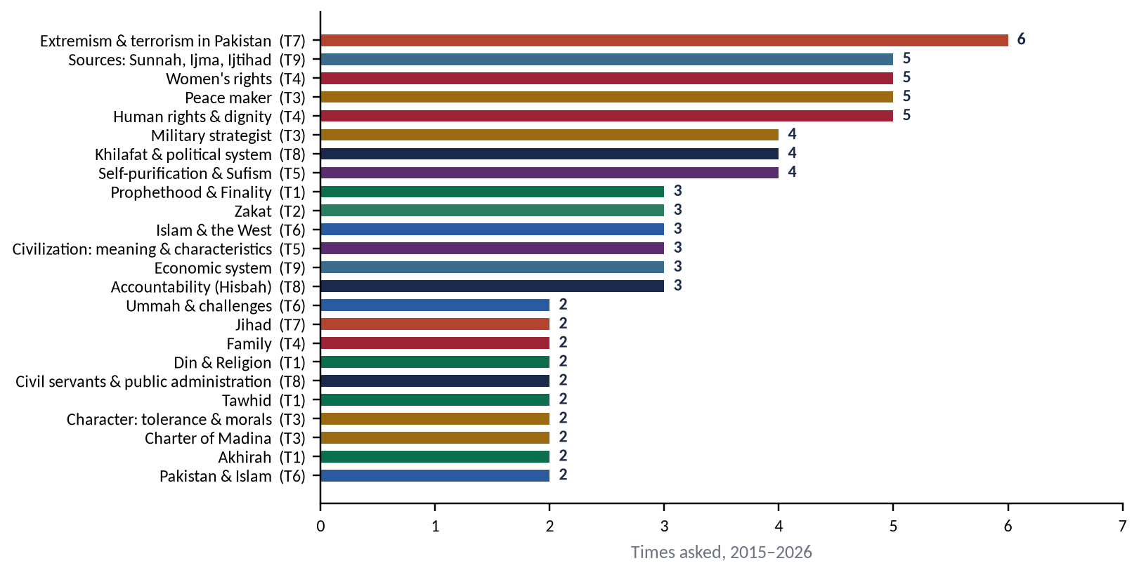
Figure 9 · The repeat engine: every family asked at least twice, 2015–2026 (topic in brackets).

The families asked three times or more
Family | Topic | Years | The angle each time
Extremism & terrorism in Pakistan | T7 | 2017, 2018, 2019, 2023, 2024, 2026 | 2017: Enumerate the reasons of extremism in Pakistan and suggest solutions to eradicate it in the light of Islamic teachings.  2018: Point out the motives of terrorism in Pakistan. How can the society get rid of terrorism?  2019: Is extremism a challenge to Islam? Discuss in the context of contemporary challenges faced by Muslim Ummah.  2023: What are the motives of extremism in Pakistan? How can the society get rid of extremism by following the teachings of Islam?  2024: How is it possible to eliminate the religious and political extremism in Pakistan in the light of the teachings of the Holy Prophet (ﷺ)? Explain.  2026: Examine the causes of sectarianism and polarization in the Muslim World. Suggest solutions in the light of Islamic teachings.
Sources: Sunnah, Ijma, Ijtihad | T9 | 2015, 2017, 2018, 2022, 2023 | 2015: Write a comprehensive note on the importance of Sunnah in interpretation and legislation.  2017: Define Ijma' (consensus) and explain its different kinds. Highlight its importance in the light of the Qur'ān and Sunnah.  2018: Define Ijtihad, also highlight its contemporary importance in the light of Islamic Fiqh.  2022: Elaborate the concept and importance of Ijtihad and explain its principles.  2023: Define Ijma (consensus) and explain its different kinds. Can legislation by a parliament of an Islamic state be regarded as a valid consensus?
Women's rights | T4 | 2017, 2019, 2021, 2022, 2023 | 2017: Write a comprehensive note on the right of inheritance granted to women by Islam.  2019: Describe the rights of women in Islam in the context of current wave of the feminist movement.  2021: Islam provides better rights to men and women than all other religions. Explore with arguments.  2022: Explain the concept of Human Rights in Islamic thought in specification of "Status of Women in Islam".  2023: Elaborate the rights of daughters granted by Islam and how these are denied by Muslims in the contemporary world?
Peace maker | T3 | 2017, 2018, 2021, 2022, 2025 | 2017: Elucidate how the Prophet of Islam (Peace be upon him) exemplified him as the greatest peace maker in the world by making reconciliation with pagans, Jews and Christians?  2018: The Holy Prophet (PBUH) is the prophet of peace and safety. Explain with arguments.  2021: Write notes on the following: (a) Treaty of Hudaybiyya as a pact of peace; (b) Benefits acquired from the Battle of Khaybar.  2022: Describe Hazrat Muhammad (ﷺ) as a Prophet of Peace for contemporary transnational world.  2025: Discuss the contents of the peace agreements made during the Prophet's era, identifying the parties to those agreements.
Human rights & dignity | T4 | 2020, 2020, 2023, 2024, 2026 | 2020: "The last Sermon of the Holy Prophet (PBUH) is the basic document for awakening of conscience of mankind for human rights". Discuss.  2020: "Islam teaches the lesson of human respect and dignity irrespective of colour, race and creed". Discuss.  2023: Write notes on the following: (i) Human rights in the light of the Sermon of the Farewell Pilgrimage; (ii) Social justice in an Islamic society.  2024: How does Islam highlight human dignity and greatness? Discuss.  2026: Provide a comparative and critical analysis of the human rights granted by Islam with those enshrined in the Universal Declaration of Human Rights (UDHR).
Military strategist | T3 | 2016, 2019, 2023, 2024 | 2016: Describe the characteristics of Military strategist in the light of Sirah of Muhammad (PBUH) with arguments.  2019: Give a general estimate of Holy Prophet's (PBUH) character in the battle fields as commander.  2023: Discuss the Holy Prophet's (ﷺ) Role as a Model for Military Strategy.  2024: The main purpose of Ghazwat-e-Nabawi was to establish peace. Explain.
Khilafat & political system | T8 | 2016, 2017, 2019, 2020 | 2016: Discuss the salient features of Islamic political system in the light of governance under pious Khilafat-i-Rashida.  2017: How were the Rightly-guided Caliphs elected? To what extent their system of government be regarded as democratic?  2019: Give suggestions to reform Pakistani Politics keeping in view the different aspects of political system of Islam.  2020: Write a comprehensive note on the bravery and juridical wisdom of Hazrat Ali (R.A).
Self-purification & Sufism | T5 | 2017, 2018, 2021, 2024 | 2017: Explain the concept of self-purification in the light of the Qur'ān and Sunnah and its impact on society.  2018: What is Self-purification and Ehsan? Explain it in the light of Quran and Sunnah, also describe its individual and collective impacts.  2021: Explore the importance of Sufism to spread out Islam. Is the amelioration of current deviation possible through Sufism?  2024: Self-purification is an essential element for the evolution of society. Explain.
Prophethood & Finality | T1 | 2015, 2022, 2024 | 2015: The entire faith in Prophethood is unacceptable without faith in finality of the Prophethood. Discuss in the light of Quran & Sunnah.  2022: Explain the doctrine of Prophethood and its importance in human life.  2024: Explain the doctrine of Prophethood and its importance in human life.
Zakat | T2 | 2015, 2017, 2018 | 2015: Highlight the importance of Zakat and prove that economic stability of a society can be ensured through its effective implementation.  2017: Who are entitled to receive Zakat according to the Quran? Elucidating social impact of Zakat, clarify how can poverty be alleviated with its distribution in Islamic Society?  2018: Write a comprehensive note on Zakat system of Islam and its spiritual, moral and social impacts.
Islam & the West | T6 | 2015, 2025, 2026 | 2015: Give a comparison of Islamic ideology and modern Western thought about present trends of individuality.  2025: What views are found in today's Muslim circles about Western Civilization? Identify and analyze them.  2026: Explain how Western civilization has influenced Islamic civilization. Discuss the measures to protect Muslim societies from the negative impacts of Western culture.
Civilization: meaning & characteristics | T5 | 2016, 2018, 2019 | 2016: What is meant by culture and civilization? Describe the characteristics of Islamic culture.  2018: Describe, in detail, the basic characteristics of Islamic civilization.  2019: Throw light in detail on the moral value system of Islam as a significant feature of Islamic civilization.
Economic system | T9 | 2020, 2022, 2025 | 2020: "Islamic Financial and Economic system is the solution of the human financial problems". Discuss.  2022: Write down the main principles of Islamic Economics. How do these principles provide solutions to contemporary challenges?  2025: What are the disadvantages of concentration of wealth? What economic measures has Islam introduced to prevent this concentration of wealth?
Accountability (Hisbah) | T8 | 2021, 2024, 2026 | 2021: Express the principles of accountability of rulers according to the Holy Quran and Sunnah.  2024: How can the system of accountability in Pakistan be idealized in the teachings of the Holy Prophet (ﷺ)? Explain.  2026: Explain the concept of accountability in the Islamic system. Demonstrate with examples that the practices of the Rashidun Caliphs in this perspective set the highest standard.

The families asked twice
Family | Topic | Years
Din & Religion | T1 | 2016, 2022
Tawhid | T1 | 2019, 2026
Akhirah | T1 | 2021, 2023
Character: tolerance & morals | T3 | 2020, 2025
Charter of Madina | T3 | 2020, 2023
Family | T4 | 2015, 2026
Ummah & challenges | T6 | 2015, 2016
Pakistan & Islam | T6 | 2022, 2026
Jihad | T7 | 2015, 2020
Civil servants & public administration | T8 | 2016, 2018

The families asked once
Family | Topic | Year
Wahi | T1 | 2015
Salah | T2 | 2016
Hajj | T2 | 2019
Fard Kifayah | T2 | 2025
Equality & social justice | T5 | 2025
Tolerance in Muslim history | T5 | 2025
Co-existence & tolerance | T6 | 2021
Islamophobia | T6 | 2021

Exact and near repeats
Some questions have come back word for word or nearly so. These are the questions you must be able to write in your sleep.
First asked | Repeated | The question
2022 Q5 | 2024 Q4 (exact) | Explain the doctrine of Prophethood and its importance in human life.
2020 Q6 | 2023 Q6 (near) | Analyze the Charter of Madinah / Madina Accord as a social contract.
2017 Q8 | 2023 Q5 (near + new limb) | Define Ijma and explain its kinds … (2023 adds: can parliament's legislation be Ijma?)
2016 Q3 | 2022 Q8 (near) | The difference between Din and religion; the importance of Din in human life.
2017 Q7 | 2018 Q4 · 2023 Q7 · 2024 Q7 | Motives/reasons of extremism (or terrorism) in Pakistan and how to get rid of it.
2016 Q4 | 2019 Q3 · 2023 Q3 | The Prophet ﷺ as military strategist / commander.
2017 Q6 | 2018 Q3 · 2024 Q2 | Self-purification: concept and impact on the individual and society.
2015 Q5 | 2017 Q2 · 2018 Q6 | Zakat: importance, recipients, impact on poverty and economic stability.
2021 Q6 | 2024 Q6 · 2026 Q6 | Accountability of rulers / in Pakistan / under the Rashidun.

EXAMINER'S EYE · THE REPEAT WITH A TWIST
When a family returns, one new limb is usually added: 2023's Ijma question adds parliament; 2024's accountability question adds Pakistan; 2026's accountability question adds the Rashidun as 'the highest standard'. A memorised answer loses marks on exactly that limb. Prepare the family, then read the twist and give it its own heading.

3.5 The leaks between topics
Many questions draw on two topics at once. Knowing the leaks lets you borrow evidence across topics — and warns you not to prepare topics in isolation.
Question | Home topic | Leaks into | What to borrow
2015 Q5 | T2 | T9 | economic system, sources of law
2015 Q9 | T6 | T5 | equality, dignity, tolerance, tazkiyah
2016 Q7 | T8 | T9 | economic system, sources of law
2017 Q2 | T2 | T9 | economic system, sources of law
2018 Q6 | T2 | T9 | economic system, sources of law
2019 Q7 | T7 | T6 | Pakistan, Ummah, West
2019 Q8 | T8 | T6 | Pakistan, Ummah, West
2020 Q5 | T7 | T3 | Sirah examples
2020 Q7 | T4 | T5 | equality, dignity, tolerance, tazkiyah
2021 Q4 | T6 | T5 | equality, dignity, tolerance, tazkiyah
2021 Q5 | T6 | T7 | extremism, Jihad
2022 Q7 | T6 | T9 | economic system, sources of law
2023 Q8 | T4 | T5 | equality, dignity, tolerance, tazkiyah
2024 Q3 | T3 | T7 | extremism, Jihad
2024 Q6 | T8 | T6 | Pakistan, Ummah, West
2024 Q7 | T7 | T3 | Sirah examples
2025 Q4 | T5 | T4 | rights, women
2025 Q5 | T9 | T2 | Zakat
2025 Q7 | T5 | T6 | Pakistan, Ummah, West
2026 Q4 | T6 | T5 | equality, dignity, tolerance, tazkiyah
2026 Q6 | T8 | T9 | economic system, sources of law
2026 Q7 | T7 | T6 | Pakistan, Ummah, West

3.6 The blind spots — syllabus lines never asked, 2015–2026
These syllabus lines have never been the direct subject of a descriptive question in twelve years. An examiner who wants a 'fresh' question will look here first.
Topic | Blind spot (never asked directly) | Risk
T1 | Distinctive aspects of Islam · the concept of Islam as such · belief in Angels, Books and Qadr | High
T2 | Sawm (fasting) — never asked · Hajj asked once · Salah once since 2016 | High
T3 | The Prophet ﷺ as Educator (the 2026 MCQ called 'teacher' his most highlighted status) · as Diplomat (letters to rulers, delegations) · as Individual | Very high
T4 | Rights of non-Muslims in an Islamic state · rights of children, the elderly, labour · the dignity of men (the syllabus says 'men and women') | High
T5 | Role of civilization in the development of human personality and community · rule of law · meaning and vital elements (only partly, 2016) | High
T6 | Impact of Islamic civilization on the West (only the reverse asked, 2026) · the role of Islam in the modern world | Very high
T7 | Rise of extremism in the Muslim world generally · Paigham-e-Pakistan as a model | Medium
T8 | Letters of Hazrat Umar and Hazrat Ali (a named syllabus line!) · Quranic guidance on good governance · Shura and legislation | Very high
T9 | Social, judicial and administrative systems · Qiyas · Maqasid al-Shariah | High

3.7 Beyond the syllabus — what the examiner asked that the syllabus never names
- Two-Nation Theory and the plight of Indian and Kashmiri Muslims (2026) — a Pakistan Affairs theme in an Islamiat paper.
- Fard Kifayah and its modern scope (2025).
- Sufism and its role in spreading Islam (2021).
- Islamophobia (2021), feminism (2019), the UDHR (2026) — contemporary Western frames.
- Hazrat Ali's bravery and juridical wisdom (2020) — a personality question.
- Classist lifestyle (2025), sectarianism and polarisation (2026), reform of Pakistani politics (2019), reconstruction of Pakistani society (2022).
The lesson: the syllabus is a floor, not a ceiling. The examiner feels free to ask anything that applies Islam to the life of a Muslim and a Pakistani. The contemporary chapters of the Knowledge Bases are built for exactly this.

3.8 The objective paper, 2015–2026
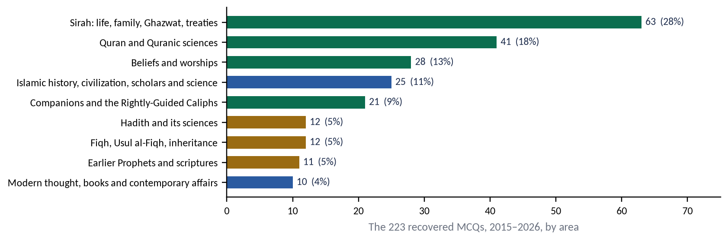
Figure 10 · What the 223 recovered MCQs test.

What the MCQs teach
- The MCQs are a different paper. The descriptive part tests concepts; the objective part tests facts — above all the Sirah (28%) and the Quran (18%).
- They repeat. At least twenty facts have been asked two or three times (below). Learn the repeats first.
- They are moving towards concepts since 2026 (the basis of honour, the condition of polygamy, the status of the Prophet most highlighted, the type of equality in the Farewell Sermon) — which rewards reading the Knowledge Bases.

MCQ facts asked more than once
Fact | Asked
Hudaybiyyah treaty written by Hazrat Ali (RA); called Fath-e-Mubin (clear victory) | 2017, 2021, 2022, 2025 (×2)
Heads of Zakat: eight, in Surah At-Tawbah | 2017, 2018, 2022, 2024
Preferring one analogy over another = Istihsan (most used by the Hanafis) | 2021, 2022, 2026
Salat al-Istisqa = prayer for rain | 2015, 2017, 2021
Kusuf = solar eclipse prayer; Khusuf = lunar eclipse prayer | 2018, 2022, 2025
Hajj sermon delivered at Masjid Nimrah (Arafat) | 2015 (×2), 2019
Last Ghazwa: Tabuk (Jaish al-Usrah, the army of hardship) | 2015, 2019, 2022
Second migration to Abyssinia: 101 people | 2016, 2023
Halimah Sa'diyyah was of Banu Sa'd | 2022 (×2), 2023
The Prophet ﷺ travelled to Syria with Abu Talib at 12 | 2015, 2023
Jadd al-Anbiya = Ibrahim (AS); Khalil Allah = Ibrahim (AS) | 2015, 2019, 2020
Longest surah: Al-Baqarah | 2016, 2018, 2020
First market inspector: Shifa bint Abdullah (RA), appointed by Hazrat Umar | 2017, 2023
First Amir al-Hajj: Hazrat Abu Bakr (RA), 9 AH | 2020, 2023
After Hazrat Khadijah (RA), the Prophet ﷺ married Hazrat Sawdah (RA) | 2018, 2023
A widow of a childless husband gets one-quarter | 2023, 2025
Hadith Taqriri = the Prophet's silent approval | 2015, 2025
Al-Itqan fi Ulum al-Quran by Jalaluddin Suyuti | 2018, 2022
Literal meaning of Wahi: to convey a message quickly/secretly (all of the above) | 2015, 2019
Ghazwa Ahzab = Khandaq (the Trench), 5 AH | 2017, 2023, 2025

3.9 How the questions are shaped
Shape | Example | How to build the answer
Define + impact | Define Tauheed. What is its impact on individual life and the society? (2019) | Definition → kinds → impact on individual (5–7 sub-heads) → impact on society (5–7 sub-heads) → today → conclusion.
Concept + importance | Explain the doctrine of Prophethood and its importance in human life. (2022, 2024) | Concept → need → qualities of Prophets → finality → importance in (i) belief (ii) morality (iii) society (iv) today.
Compare / differentiate | Differentiate between Deen and religion (2016, 2022); Islam vs UDHR (2026) | Define both → comparison table (figure) → point-by-point headings → evaluation.
Role / model | The Prophet's role as a model for military strategy (2023) | Principles → battle-by-battle application → lessons for today.
Problem → solution (Pakistan) | Motives of extremism in Pakistan; how to get rid of it (2023) | Define → causes (headed by type) → Islamic teachings → solutions (headed by actor: state, scholars, education, media, family).
Statement: 'Discuss' | "Islamic economic system is the solution…" (2020) | Agree with a thesis → prove each part → answer objections → conclude.
Critical / analytical | Views in Muslim circles about Western civilization — identify and analyze (2025) | Classify the views (figure) → each view: claim, evidence, strengths, weaknesses → the balanced Islamic position.
Short notes (10 + 10) | Treaty of Hudaybiyyah as a pact of peace; benefits of Khaybar (2021) | Half-size answers: definition/background → 4–6 headed points → evidence → one-line conclusion.

3.10 The command words, decoded
Command word (asked) | What it demands | Heading pattern
Define | Literal and technical meaning, with source | (1) Literal meaning (2) Technical meaning (3) In the Quran and Sunnah
Explain / Elaborate / Elucidate | Make clear, with reasons and examples | Concept → aspects → evidence → examples
Describe | Give the features in order | Feature 1, 2, 3 … each proved
Discuss | Examine from several sides and conclude | Thesis → arguments → counter-view → verdict
Highlight / Throw light / Point out | Bring out the main points clearly | Short, many headings
Enumerate | List and number, then explain | Numbered headings (1)…(10)
Analyze / Examine | Break into parts, test each part | Parts → strengths → weaknesses → assessment
Argue / Prove / Justify | Take a side and defend it with evidence | Claim → proofs (rational, Quranic, historical) → objections answered
Compare / Differentiate / Critical comparison | Similarities and differences, and a judgement | Table + point-by-point headings + evaluation
Comment / Explore / Express | Give an informed view | Context → teachings → application → view
Determine / Assess / To what extent | Measure; give a qualified verdict | The case for → the case against → verdict
Suggest / Give suggestions / How can… | Practical, numbered solutions | Solutions by actor: state, ulema, education, media, family, individual

3.11 What changed between 2015 and 2026
Phase | Style of question | Examples
2015 | Old scheme (16 marks, five of eight). Broad concepts. | Ummah, Jihad, Finality, Zakat, Sunnah, Wahi, family, individuality
2016–2019 | Conceptual: define, describe characteristics, spiritual/moral/social impact. | Din vs religion; prayer; Zakat; self-purification; characteristics of civilization; Tauheed
2020–2023 | Contextual: the concept in a frame — social contract, feminism, Pakistan, multi-faith society. | Madina Accord as social contract; women and feminism; co-existence; Islamophobia; parliament and Ijma
2024–2026 | Applied and critical: 'in Pakistan', 'in the light of the Prophet's teachings', 'comparative and critical analysis', 'identify and analyze'. | Accountability in Pakistan; extremism through the Prophet's teachings; classism; wealth concentration; UDHR; Western influence; sectarianism; rational proofs of Allah

EXAMINER'S EYE · THE DIRECTION OF TRAVEL
The paper has moved from 'What does Islam say?' to 'How does what Islam says solve this problem now?' Every answer you write should therefore end its body with an applied section — and many should be built around it.

3.12 Where the next paper could come from
Combine the three forces — the repeat engine, the blind spots and the contemporary layer — and the next paper becomes predictable in outline, if not in wording.

Tier 1 — prepare to full-answer depth from every angle
1. Extremism / terrorism / sectarianism — causes and cures, in Pakistan and the Muslim world (T7). Asked six times.
2. Women's rights / human rights / human dignity — against feminism, the UDHR or Pakistani practice (T4).
3. The Prophet ﷺ as peace maker / military strategist — and the untouched Educator and Diplomat (T3).
4. Prophethood and its finality; Tawhid; Akhirah; Din vs religion (T1).
5. Accountability and the conduct of the Rashidun; civil servants; letters of Umar and Ali (T8).
6. Self-purification / Ihsan / moral values (T5).

Tier 2 — prepare to a full plan and a strong short answer
1. Worships — especially Sawm (never asked) and Zakat against poverty (T2).
2. Ijma / Ijtihad / Sunnah; the Islamic economic system; riba (T9).
3. Islam and the West — both directions of impact; Islamophobia; Muslim Ummah and its revival (T6).
4. The family in the present era (T4).

Tier 3 — the blind spots most likely to be broken
- The Prophet ﷺ as Educator / teacher of humanity.
- Letters of Hazrat Umar and Hazrat Ali to their governors, and their lessons for Pakistan's civil servants.
- Impact of Islamic civilization on the West.
- Rights of non-Muslims / minorities in an Islamic state.
- Distinctive features of Islam.
- Quranic guidance on good governance; Shura.
- The judicial system of Islam and the rule of law.
- Role of civilization in building the human personality and community.

Part Four — The Nine Topic Dossiers
Each dossier is the brief for one topic. Read it before you open that topic's Knowledge Base, and again when you revise it. It tells you what the syllabus says, what the examiner has asked, what the record reveals, what the contemporary layer holds, what has never been asked, and the few pieces of evidence that carry the whole topic.

T1 · Introduction to Islam and the Islamic Beliefs

What the syllabus asks for
- Concept of Islam
- Importance of Din in human life
- Difference between Din and religion
- Distinctive aspects of Islam
- Islamic beliefs and their impact on individual and society; the fundamentals of Islam

What the examiner has asked
Year | Question
2015 Q4 | The entire faith in Prophethood is unacceptable without faith in finality of the Prophethood. Discuss in the light of Quran & Sunnah.
2015 Q7 | Argue for supremacy of 'Wahi' as the solution of human problems against other sources of knowledge.
2016 Q3 | What is the difference between Deen and Religion? Describe the importance of Deen in human life with arguments.
2019 Q2 | Define Tauheed. What is its impact on individual life and the society? Elaborate.
2021 Q2 | What is belief in the Day of Judgment? Explore its effects on individual and collective lives of human beings.
2022 Q5 | Explain the doctrine of Prophethood and its importance in human life.
2022 Q8 | Describe the importance of Deen (Doctrine of life) in human life. Differentiate between Deen and Religions.
2023 Q2 | What is the Qur'anic argument on the Life Hereafter? What are its impacts on the individual and collective life of a human being?
2024 Q4 | Explain the doctrine of Prophethood and its importance in human life.
2026 Q5 | What are the rational arguments for the existence of Allah? Explain the impacts of the belief in monotheism on human life.

What the record reveals
- Asked ten times — the third-heaviest topic, and asked in 2022, 2023, 2024 and 2026 running.
- Prophethood is the favourite belief: finality (2015), doctrine and importance (2022, repeated word for word in 2024).
- 'Impact on individual and society' is attached to almost every belief question (Tawhid 2019, Akhirah 2021 and 2023, monotheism 2026). Prepare every belief with two impact lists ready.
- Din vs religion returned after six years (2016 → 2022) with the same two limbs.
- 2026 asked for rational arguments for the existence of Allah — a sign that the examiner wants reasoning, not only scripture.

The contemporary layer
- Atheism, scepticism and 'new atheism' among educated youth — the rational and Quranic answer
- Science and religion: conflict or harmony? The Quran's invitation to observe (tafakkur)
- Secularism and the narrative that 'religion is a private matter' — the answer of Din
- The meaning crisis: anxiety, depression and loneliness, and the peace of Tawhid and Akhirah
- Finality of Prophethood and its protection in the Constitution of Pakistan

Blind spots and five likely questions
Never asked directly: Distinctive aspects of Islam · The concept of Islam as a whole · Belief in Angels, Books and Qadr · The fundamentals of Islam as a system.
1. What are the distinctive features of Islam that make it a complete code of life? Discuss.
2. Explain the concept of Islam and prove that it is the Din of all the Prophets.
3. Belief in the Hereafter is the basis of moral life. Discuss with Quranic arguments.
4. How does belief in Tawhid remove the crises of modern man? Explain.
5. Revelation (Wahi) is the only certain source of guidance. Argue against the claims of pure reason and science.

The core evidence in one page
If you remember nothing else of this topic, remember these. Each will be met again, in its place, in the Knowledge Base.
✦ QURAN
﴿إِنَّ ٱلدِّينَ عِندَ ٱللَّهِ ٱلۡإِسۡلَٰمُۗ وَمَا ٱخۡتَلَفَ ٱلَّذِينَ أُوتُواْ ٱلۡكِتَٰبَ إِلَّا مِنۢ بَعۡدِ مَا جَآءَهُمُ ٱلۡعِلۡمُ بَغۡيَۢا بَيۡنَهُمۡۗ وَمَن يَكۡفُرۡ بِـَٔايَٰتِ ٱللَّهِ فَإِنَّ ٱللَّهَ سَرِيعُ ٱلۡحِسَابِ﴾
“Indeed, the religion in the sight of Allah is Islam. And those who were given the Scripture did not differ except after knowledge had come to them - out of jealous animosity between themselves. And whoever disbelieves in the verses of Allah, then indeed, Allah is swift in [taking] account.” (Aal-e-Imran, Quran)
➜ Islam is the Din — the whole way of life — accepted by Allah: the key verse for the concept of Islam and for Din vs religion.

✦ QURAN
﴿قُلۡ هُوَ ٱللَّهُ أَحَدٌ ۝ ٱللَّهُ ٱلصَّمَدُ ۝ لَمۡ يَلِدۡ وَلَمۡ يُولَدۡ ۝ وَلَمۡ يَكُن لَّهُۥ كُفُوًا أَحَدُۢ﴾
“Say, "He is Allah, [who is] One. Allah, the Eternal Refuge. He neither begets nor is born. Nor is there to Him any equivalent.” (Al-Ikhlas, Quran)
➜ Tawhid in four short verses: Allah is One, self-sufficient, unbegotten, without equal — the heart of every belief answer.

✦ QURAN
﴿مَّا كَانَ مُحَمَّدٌ أَبَآ أَحَدٖ مِّن رِّجَالِكُمۡ وَلَٰكِن رَّسُولَ ٱللَّهِ وَخَاتَمَ ٱلنَّبِيِّـۧنَۗ وَكَانَ ٱللَّهُ بِكُلِّ شَيۡءٍ عَلِيمٗا﴾
“Muhammad is not the father of [any] one of your men, but [he is] the Messenger of Allah and last of the prophets. And ever is Allah, of all things, Knowing.” (Al-Ahzab, Quran)
➜ The explicit text of the Finality of Prophethood: Khatam an-Nabiyyin, the seal of the Prophets.

✦ HADITH
أَمَا تَرْضَى أَنْ تَكُونَ مِنِّي بِمَنْزِلَةِ هَارُونَ مِنْ مُوسَى، إِلَّا أَنَّهُ لَا نَبِيَّ بَعْدِي
“Are you not pleased to be to me as Harun was to Musa — except that there is no Prophet after me?” (Al-Bukhari and Muslim)
➜ Said to Hazrat Ali (RA): the Sunnah confirms the Quran — no Prophet after Muhammad ﷺ.

✦ SCHOLARLY VIEW
Allama Muhammad Iqbal · The Reconstruction of Religious Thought in Islam
“In Islam prophecy reaches its perfection in discovering the need of its own abolition.”
➜ Finality is not a limitation but a completion: humanity now has a final, complete guidance and must use reason under it.

What the T1 documents will carry
T1KB — the chapters (each divided to four or five levels of headings; the Knowledge Base adds Part Zero, the record, five likely questions, the one-liners and the revision sheet):
Ch. 1 The Concept of Islam
Ch. 2 Din: Meaning and Importance in Human Life
Ch. 3 Din and Religion: The Difference
Ch. 4 The Distinctive Aspects of Islam
Ch. 5 Wahi: Revelation and Its Supremacy over Other Sources of Knowledge
Ch. 6 Tawhid: Concept, Kinds, Rational Arguments and Impact
Ch. 7 Risalat: The Doctrine of Prophethood and Its Importance
Ch. 8 Khatm-e-Nubuwwat: The Finality of Prophethood
Ch. 9 Akhirah: The Quranic Argument and Its Impact
Ch. 10 Angels, Books and Qadr
Ch. 11 The Islamic Beliefs Together: Impact on the Individual and Society
Ch. 12 Contemporary Challenges, Narratives and Hot Debates
T1QA answers all 10 past questions above as full model answers.

T2 · Islamic Worships (Ibadat) and Their Impact

What the syllabus asks for
- Islamic worships: spiritual, moral and social impact

What the examiner has asked
Year | Question
2015 Q5 | Highlight the importance of Zakat and prove that economic stability of a society can be ensured through its effective implementation.
2016 Q5 | Define the meaning of prayer and its different categories. Also describe the spiritual, moral and social impact of prayers.
2017 Q2 | Who are entitled to receive Zakat according to the Quran? Elucidating social impact of Zakat, clarify how can poverty be alleviated with its distribution in Islamic Society?
2018 Q6 | Write a comprehensive note on Zakat system of Islam and its spiritual, moral and social impacts.
2019 Q6 | Write a comprehensive note on Hajj (the pilgrimage) system of Islam and its spiritual, moral and social impacts.
2025 Q3 | What is meant by Farz Kifayah? What is its religious and social significance? In the present era, which affairs are considered to be included in the scope of Farz Kifayah?

What the record reveals
- Zakat is the favourite — three times in four years (2015, 2017, 2018), always tied to poverty and economic stability.
- The fixed formula is 'spiritual, moral and social impact' (2016 prayer, 2018 Zakat, 2019 Hajj). Prepare each worship with these three headings.
- 2025 opened a new door: Fard Kifayah — the collective duties of the Ummah and their modern scope.
- Sawm has never been asked, and Salah only once — both are overdue.

The contemporary layer
- Worship reduced to ritual: why prayer does not always stop corruption — and what the Quran says about it
- Zakat and poverty in Pakistan: the government Zakat system, the trust deficit and private giving
- Hajj and Umrah: cost, commercialisation and the spirit of equality
- Fard Kifayah in the modern age: research, medicine, defence, AI, climate, clean government
- Ramadan, price-hikes and hoarding — the moral test of worship

Blind spots and five likely questions
Never asked directly: Sawm (fasting) — never asked · Worship (Ibadah) in its wide sense · Salah since 2016; Hajj since 2019.
1. Discuss the spiritual, moral and social impacts of fasting (Sawm).
2. Explain the Islamic concept of Ibadah. How is the whole of life an act of worship?
3. Zakat is the solution to poverty in Pakistan. Discuss with a plan for its effective collection and distribution.
4. Salah is the training of a disciplined society. Explain.
5. Hajj is the annual assembly of the Muslim Ummah. Discuss its role in the unity of the Ummah.

The core evidence in one page
If you remember nothing else of this topic, remember these. Each will be met again, in its place, in the Knowledge Base.
✦ QURAN
﴿ٱتۡلُ مَآ أُوحِيَ إِلَيۡكَ مِنَ ٱلۡكِتَٰبِ وَأَقِمِ ٱلصَّلَوٰةَۖ إِنَّ ٱلصَّلَوٰةَ تَنۡهَىٰ عَنِ ٱلۡفَحۡشَآءِ وَٱلۡمُنكَرِۗ وَلَذِكۡرُ ٱللَّهِ أَكۡبَرُۗ وَٱللَّهُ يَعۡلَمُ مَا تَصۡنَعُونَ﴾
“Recite, [O Muhammad], what has been revealed to you of the Book and establish prayer. Indeed, prayer prohibits immorality and wrongdoing, and the remembrance of Allah is greater. And Allah knows that which you do.” (Al-Ankabut, Quran)
➜ Prayer restrains from indecency and wrongdoing — the moral impact of Salah in the Quran's own words.

✦ QURAN
﴿۞إِنَّمَا ٱلصَّدَقَٰتُ لِلۡفُقَرَآءِ وَٱلۡمَسَٰكِينِ وَٱلۡعَٰمِلِينَ عَلَيۡهَا وَٱلۡمُؤَلَّفَةِ قُلُوبُهُمۡ وَفِي ٱلرِّقَابِ وَٱلۡغَٰرِمِينَ وَفِي سَبِيلِ ٱللَّهِ وَٱبۡنِ ٱلسَّبِيلِۖ فَرِيضَةٗ مِّنَ ٱللَّهِۗ وَٱللَّهُ عَلِيمٌ حَكِيمٞ﴾
“Zakah expenditures are only for the poor and for the needy and for those employed to collect [zakah] and for bringing hearts together [for Islam] and for freeing captives [or slaves] and for those in debt and for the cause of Allah and for the [stranded] traveler - an obligation [imposed] by Allah. And Allah is Knowing and Wise.” (At-Tawbah, Quran)
➜ The eight heads of Zakat: the Quran itself fixes who receives it — the key verse for 2017.

✦ QURAN
﴿يَـٰٓأَيُّهَا ٱلَّذِينَ ءَامَنُواْ كُتِبَ عَلَيۡكُمُ ٱلصِّيَامُ كَمَا كُتِبَ عَلَى ٱلَّذِينَ مِن قَبۡلِكُمۡ لَعَلَّكُمۡ تَتَّقُونَ﴾
“O you who have believed, decreed upon you is fasting as it was decreed upon those before you that you may become righteous.” (Al-Baqarah, Quran)
➜ The purpose of fasting is taqwa — the spiritual impact (an MCQ in 2017).

✦ HADITH
تُؤْخَذُ مِنْ أَغْنِيَائِهِمْ فَتُرَدُّ عَلَى فُقَرَائِهِمْ
“[Zakat] is to be taken from their rich and returned to their poor.” (Al-Bukhari and Muslim)
➜ Said when sending Hazrat Mu'adh (RA) to Yemen: Zakat is a system of circulation from rich to poor within the society.

✦ SCHOLARLY VIEW
Imam Al-Ghazali · Ihya Ulum al-Din
In Ihya Ulum al-Din, Ghazali explains that the value of prayer lies in its inner meanings — presence of heart, understanding, reverence, awe, hope and shame before Allah; without them the outward form does not change the soul.
➜ Worship changes character only when it is performed with presence of heart — the spiritual root of the moral impact.

What the T2 documents will carry
T2KB — the chapters (each divided to four or five levels of headings; the Knowledge Base adds Part Zero, the record, five likely questions, the one-liners and the revision sheet):
Ch. 1 Ibadah: The Concept of Worship in Islam
Ch. 2 Salah: Meaning, Categories and Impact
Ch. 3 Zakat: The System, Its Recipients and Its Impact
Ch. 4 Zakat, Poverty and Economic Stability
Ch. 5 Sawm: Fasting and Its Impact
Ch. 6 Hajj: The System and Its Impact
Ch. 7 Fard Ayn and Fard Kifayah
Ch. 8 The Worships Together: Spiritual, Moral and Social Impact
Ch. 9 Contemporary Challenges, Narratives and Hot Debates
T2QA answers all 6 past questions above as full model answers.

T3 · The Sirah of the Prophet ﷺ as Role Model

What the syllabus asks for
- The Sirah of the Prophet Muhammad ﷺ as role model for the individual
- … as diplomat
- … as educator
- … as military strategist
- … as peace maker

What the examiner has asked
Year | Question
2016 Q4 | Describe the characteristics of Military strategist in the light of Sirah of Muhammad (PBUH) with arguments.
2017 Q5 | Elucidate how the Prophet of Islam (Peace be upon him) exemplified him as the greatest peace maker in the world by making reconciliation with pagans, Jews and Christians?
2018 Q8 | The Holy Prophet (PBUH) is the prophet of peace and safety. Explain with arguments.
2019 Q3 | Give a general estimate of Holy Prophet's (PBUH) character in the battle fields as commander.
2020 Q2 | Discuss the status and grade of "Tolerance and Forgiveness" in the life of the Holy Prophet (PBUH).
2020 Q6 | Analyze the Madina Accord as a "Social Contract" in detail.
2021 Q8 | Write notes on the following: (a) Treaty of Hudaybiyya as a pact of peace; (b) Benefits acquired from the Battle of Khaybar.
2022 Q6 | Describe Hazrat Muhammad (ﷺ) as a Prophet of Peace for contemporary transnational world.
2023 Q3 | Discuss the Holy Prophet's (ﷺ) Role as a Model for Military Strategy.
2023 Q6 | Analyze the Charter of Madina as a social contract.
2024 Q3 | The main purpose of Ghazwat-e-Nabawi was to establish peace. Explain.
2025 Q2 | What is the importance of Makarim Akhlaq (noble morals) in establishing social peace? In this background, how did the Messenger of Allah complete these morals?
2025 Q6 | Discuss the contents of the peace agreements made during the Prophet's era, identifying the parties to those agreements.

What the record reveals
- The heaviest topic: thirteen questions (including the 2021 short notes).
- Peace dominates: peace maker (2017), prophet of peace (2018), prophet of peace for the transnational world (2022), Ghazwat for peace (2024), peace agreements (2025), Hudaybiyyah as a pact of peace (2021).
- Military strategy three times (2016, 2019, 2023) — and 2024 joins war to peace.
- The Charter of Madinah as a social contract — twice (2020, 2023).
- Character: tolerance and forgiveness (2020), Makarim al-Akhlaq (2025).
- Educator and Diplomat have never been asked directly — although they are named in the syllabus.

The contemporary layer
- The Prophet ﷺ as a model for a transnational, multicultural world
- Responding to insults against the Prophet ﷺ: the lawful and dignified Prophetic way
- Leadership and management lessons from the Sirah
- The Prophet ﷺ as educator in an age of AI and information overload
- Just war and the protection of civilians: the Prophetic rules and modern humanitarian law

Blind spots and five likely questions
Never asked directly: The Prophet ﷺ as Educator · The Prophet ﷺ as Diplomat (letters to rulers, delegations) · The Prophet ﷺ as Individual.
1. The Holy Prophet ﷺ was the greatest teacher of humanity. Discuss his role as an educator.
2. Describe the diplomacy of the Holy Prophet ﷺ with reference to his letters to the rulers and his treaties.
3. The life of the Holy Prophet ﷺ is a perfect model for the individual. Explain.
4. Discuss the Conquest of Makkah as the greatest example of forgiveness and peace in history.
5. Analyse the principles of war and peace laid down by the Holy Prophet ﷺ and their relevance to modern international law.

The core evidence in one page
If you remember nothing else of this topic, remember these. Each will be met again, in its place, in the Knowledge Base.
✦ QURAN
﴿لَّقَدۡ كَانَ لَكُمۡ فِي رَسُولِ ٱللَّهِ أُسۡوَةٌ حَسَنَةٞ لِّمَن كَانَ يَرۡجُواْ ٱللَّهَ وَٱلۡيَوۡمَ ٱلۡأٓخِرَ وَذَكَرَ ٱللَّهَ كَثِيرٗا﴾
“There has certainly been for you in the Messenger of Allah an excellent pattern for anyone whose hope is in Allah and the Last Day and [who] remembers Allah often.” (Al-Ahzab, Quran)
➜ The Prophet ﷺ is the Uswah Hasanah — the excellent pattern for every role: the opening verse of any Sirah answer.

✦ QURAN
﴿وَمَآ أَرۡسَلۡنَٰكَ إِلَّا رَحۡمَةٗ لِّلۡعَٰلَمِينَ﴾
“And We have not sent you, [O Muhammad], except as a mercy to the worlds.” (Al-Anbiya, Quran)
➜ He was sent as a mercy to all the worlds — the key verse for peace maker and tolerance.

✦ QURAN
﴿هُوَ ٱلَّذِي بَعَثَ فِي ٱلۡأُمِّيِّـۧنَ رَسُولٗا مِّنۡهُمۡ يَتۡلُواْ عَلَيۡهِمۡ ءَايَٰتِهِۦ وَيُزَكِّيهِمۡ وَيُعَلِّمُهُمُ ٱلۡكِتَٰبَ وَٱلۡحِكۡمَةَ وَإِن كَانُواْ مِن قَبۡلُ لَفِي ضَلَٰلٖ مُّبِينٖ﴾
“It is He who has sent among the unlettered a Messenger from themselves reciting to them His verses and purifying them and teaching them the Book and wisdom - although they were before in clear error.” (Al-Jumu'ah, Quran)
➜ His four functions: reciting, purifying, teaching the Book and teaching wisdom — the key verse for the Prophet as educator.

✦ HADITH
إِنَّ اللَّهَ لَمْ يَبْعَثْنِي مُعَنِّتًا وَلَا مُتَعَنِّتًا، وَلَكِنْ بَعَثَنِي مُعَلِّمًا مُيَسِّرًا
“Allah did not send me to be harsh or to cause hardship; rather, He sent me to teach and to make things easy.” (Muslim)
➜ In his own words, the Prophet ﷺ was sent as a teacher who makes things easy — the answer to the 2026 MCQ, and to a future Educator question.

✦ SCHOLARLY VIEW
Michael H. Hart · The 100: A Ranking of the Most Influential Persons in History (1978)
“My choice of Muhammad to lead the list of the world's most influential persons may surprise some readers and may be questioned by others, but he was the only man in history who was supremely successful on both the religious and secular levels.”
➜ A non-Muslim historian's verdict: the Prophet ﷺ succeeded as a spiritual guide and as a statesman — use it in any 'role model' conclusion.

What the T3 documents will carry
T3KB — the chapters (each divided to four or five levels of headings; the Knowledge Base adds Part Zero, the record, five likely questions, the one-liners and the revision sheet):
Ch. 1 The Sirah: Sources and the Universal Model (Uswah Hasanah)
Ch. 2 The Prophet ﷺ as a Model for the Individual
Ch. 3 Makarim al-Akhlaq: Tolerance, Forgiveness and Noble Character
Ch. 4 The Prophet ﷺ as Educator
Ch. 5 The Prophet ﷺ as Diplomat
Ch. 6 The Prophet ﷺ as Military Strategist: Principles and the Ghazwat
Ch. 7 The Purpose of the Ghazwat: War for Peace
Ch. 8 The Prophet ﷺ as Peace Maker
Ch. 9 The Charter of Madinah as a Social Contract
Ch. 10 The Treaty of Hudaybiyyah and the Peace Agreements of the Prophetic Era
Ch. 11 The Battle of Khaybar and Its Benefits
Ch. 12 Contemporary Challenges, Narratives and Hot Debates
T3QA answers all 13 past questions above as full model answers.

T4 · Human Rights, Human Dignity, Women and the Family

What the syllabus asks for
- Human rights and status of woman in Islam
- Dignity of men and women

What the examiner has asked
Year | Question
2015 Q8 | Stability of modern society depends upon a strong family system in the light of Islamic principles. Discuss.
2017 Q3 | Write a comprehensive note on the right of inheritance granted to women by Islam.
2019 Q4 | Describe the rights of women in Islam in the context of current wave of the feminist movement.
2020 Q4 | "The last Sermon of the Holy Prophet (PBUH) is the basic document for awakening of conscience of mankind for human rights". Discuss.
2020 Q7 | "Islam teaches the lesson of human respect and dignity irrespective of colour, race and creed". Discuss.
2021 Q3 | Islam provides better rights to men and women than all other religions. Explore with arguments.
2022 Q2 | Explain the concept of Human Rights in Islamic thought in specification of "Status of Women in Islam".
2023 Q4 | Elaborate the rights of daughters granted by Islam and how these are denied by Muslims in the contemporary world?
2023 Q8 | Write notes on the following: (i) Human rights in the light of the Sermon of the Farewell Pilgrimage; (ii) Social justice in an Islamic society.
2024 Q5 | How does Islam highlight human dignity and greatness? Discuss.
2026 Q2 | Provide a comparative and critical analysis of the human rights granted by Islam with those enshrined in the Universal Declaration of Human Rights (UDHR).
2026 Q8 | What are the challenges for the 'institution of family and its role' in the present era? Discuss them in the light of Islamic teachings.

What the record reveals
- Twelve questions — second only to T3; asked in nine of the twelve years.
- Women's rights five times, each in a new frame: inheritance (2017), feminism (2019), better than other religions (2021), human rights (2022), daughters (2023).
- Human rights and dignity: the Farewell Sermon (2020 and the 2023 note), dignity irrespective of colour and creed (2020), human dignity (2024), Islam vs the UDHR (2026).
- The family twice (2015, 2026) — always 'in the present era'.
- The examiner likes the honest admission: 'how these are denied by Muslims' (2023). Prepare the gap between teaching and practice.

The contemporary layer
- The UDHR and the Cairo Declaration: a comparative and critical view
- Feminism and women's-rights movements in Pakistan — the balanced Islamic answer
- Denial of inheritance, forced marriage, honour killing, dowry — cultural practices against Islam
- Family breakdown: divorce, social media, the generation gap, working parents
- Rights of the elderly, children and persons with disabilities; child labour

Blind spots and five likely questions
Never asked directly: Rights of non-Muslims in an Islamic state · Rights of children, the elderly and workers · The dignity of men (the syllabus says 'men and women').
1. Discuss the rights of non-Muslims (minorities) in an Islamic state in the light of the Quran, Sunnah and the Charter of Madinah.
2. Islam guarantees the economic rights of women. Explain with reference to mahr, maintenance, inheritance and property.
3. What is the Islamic concept of human dignity? How does it differ from the Western concept?
4. Discuss the rights and duties of husband and wife, and the role of the family in the stability of society.
5. Islam protects the rights of children and the elderly. Discuss in the context of Pakistani society.

The core evidence in one page
If you remember nothing else of this topic, remember these. Each will be met again, in its place, in the Knowledge Base.
✦ QURAN
﴿۞وَلَقَدۡ كَرَّمۡنَا بَنِيٓ ءَادَمَ وَحَمَلۡنَٰهُمۡ فِي ٱلۡبَرِّ وَٱلۡبَحۡرِ وَرَزَقۡنَٰهُم مِّنَ ٱلطَّيِّبَٰتِ وَفَضَّلۡنَٰهُمۡ عَلَىٰ كَثِيرٖ مِّمَّنۡ خَلَقۡنَا تَفۡضِيلٗا﴾
“And We have certainly honored the children of Adam and carried them on the land and sea and provided for them of the good things and preferred them over much of what We have created, with [definite] preference.” (Al-Isra, Quran)
➜ Human dignity is a gift of Allah to all the children of Adam — not earned by race, class or creed: the key verse for every human-rights answer.

✦ QURAN
﴿يَـٰٓأَيُّهَا ٱلنَّاسُ إِنَّا خَلَقۡنَٰكُم مِّن ذَكَرٖ وَأُنثَىٰ وَجَعَلۡنَٰكُمۡ شُعُوبٗا وَقَبَآئِلَ لِتَعَارَفُوٓاْۚ إِنَّ أَكۡرَمَكُمۡ عِندَ ٱللَّهِ أَتۡقَىٰكُمۡۚ إِنَّ ٱللَّهَ عَلِيمٌ خَبِيرٞ﴾
“O mankind, indeed We have created you from male and female and made you peoples and tribes that you may know one another. Indeed, the most noble of you in the sight of Allah is the most righteous of you. Indeed, Allah is Knowing and Acquainted.” (Al-Hujurat, Quran)
➜ Equality of all human beings; the only measure of honour is taqwa (an MCQ in 2026).

✦ QURAN
﴿لِّلرِّجَالِ نَصِيبٞ مِّمَّا تَرَكَ ٱلۡوَٰلِدَانِ وَٱلۡأَقۡرَبُونَ وَلِلنِّسَآءِ نَصِيبٞ مِّمَّا تَرَكَ ٱلۡوَٰلِدَانِ وَٱلۡأَقۡرَبُونَ مِمَّا قَلَّ مِنۡهُ أَوۡ كَثُرَۚ نَصِيبٗا مَّفۡرُوضٗا﴾
“For men is a share of what the parents and close relatives leave, and for women is a share of what the parents and close relatives leave, be it little or much - an obligatory share.” (An-Nisa, Quran)
➜ Women's right to inherit is fixed by the Quran itself — little or much, an obligatory share.

✦ HADITH
إِنَّ دِمَاءَكُمْ وَأَمْوَالَكُمْ حَرَامٌ عَلَيْكُمْ، كَحُرْمَةِ يَوْمِكُمْ هَذَا، فِي شَهْرِكُمْ هَذَا، فِي بَلَدِكُمْ هَذَا
“Your blood and your property are sacred to you, as sacred as this day of yours, in this month of yours, in this city of yours.” (Muslim)
➜ The Farewell Sermon declares the sanctity of life and property — the first universal charter of human rights (2020, 2023).

✦ SCHOLARLY VIEW
Hazrat Umar Farooq (RA) · Second Rightly-Guided Caliph, to his governor of Egypt
“Since when have you enslaved people when their mothers bore them free?”
➜ Said when the governor's son had struck an Egyptian commoner: freedom and equality before the law belong to every citizen.

What the T4 documents will carry
T4KB — the chapters (each divided to four or five levels of headings; the Knowledge Base adds Part Zero, the record, five likely questions, the one-liners and the revision sheet):
Ch. 1 Human Rights in Islam: Concept, Sources and Features
Ch. 2 The Farewell Sermon: The Charter of Human Rights
Ch. 3 Islam and the UDHR: A Comparative and Critical Analysis
Ch. 4 Human Dignity and Equality: Men and Women, Colour, Race and Creed
Ch. 5 The Status of Women: Before Islam and in Islam
Ch. 6 Women as Daughter, Wife, Mother and Citizen
Ch. 7 The Economic Rights of Women: Mahr, Nafaqah, Inheritance
Ch. 8 Women's Rights and the Feminist Movement
Ch. 9 The Rights of Non-Muslims, Children, the Elderly and Workers
Ch. 10 The Institution of the Family and Its Challenges
Ch. 11 Contemporary Challenges, Narratives and Hot Debates
T4QA answers all 12 past questions above as full model answers.

T5 · Islamic Civilization and Culture

What the syllabus asks for
- Meanings and the vital elements of civilization
- Role of civilization in the development of human personality and community
- Characteristics of Islamic civilization: Tawhid, self-purification, dignity of man, equality, social justice, moral values, tolerance, rule of law

What the examiner has asked
Year | Question
2016 Q2 | What is meant by culture and civilization? Describe the characteristics of Islamic culture.
2017 Q6 | Explain the concept of self-purification in the light of the Qur'ān and Sunnah and its impact on society.
2018 Q3 | What is Self-purification and Ehsan? Explain it in the light of Quran and Sunnah, also describe its individual and collective impacts.
2018 Q7 | Describe, in detail, the basic characteristics of Islamic civilization.
2019 Q5 | Throw light in detail on the moral value system of Islam as a significant feature of Islamic civilization.
2021 Q7 | Explore the importance of Sufism to spread out Islam. Is the amelioration of current deviation possible through Sufism?
2024 Q2 | Self-purification is an essential element for the evolution of society. Explain.
2025 Q4 | Determine the status of the classist lifestyle in the light of the teachings of Islam and examine its effects on human society.
2025 Q7 | Discuss religious tolerance in the context of post-Prophetic Muslim history.

What the record reveals
- Self-purification is the favourite — 2017, 2018 (with Ihsan), 2024; plus Sufism in 2021.
- Characteristics of Islamic culture/civilization in 2016 and 2018; moral values in 2019.
- The eight named characteristics are questions in waiting: equality came as 'classist lifestyle' (2025), social justice as a 2023 note, tolerance as 'post-Prophetic history' (2025).
- The line on personality and community has never been asked.

The contemporary layer
- Materialism, consumerism and status competition — the classist lifestyle
- Moral decline, corruption and the loss of trust in Pakistani society
- Sufism: its true teaching and the deviations of shrine culture
- Digital ethics: social media, privacy, backbiting and fake news (Al-Hujurat)
- Tolerance in a polarised society

Blind spots and five likely questions
Never asked directly: Role of civilization in building the personality and the community · Rule of law as a characteristic · Dignity of man as a characteristic.
1. What are the vital elements of a civilization? Explain the role of Islamic civilization in the development of human personality.
2. Rule of law is the hallmark of Islamic civilization. Discuss with examples from the Prophetic and Rashidun eras.
3. Social justice is the foundation of an Islamic society. Explain.
4. Explain the moral system of Islam and its superiority over secular ethics.
5. Discuss the contribution of Sufis to the spread of Islam in the subcontinent.

The core evidence in one page
If you remember nothing else of this topic, remember these. Each will be met again, in its place, in the Knowledge Base.
✦ QURAN
﴿قَدۡ أَفۡلَحَ مَن زَكَّىٰهَا ۝ وَقَدۡ خَابَ مَن دَسَّىٰهَا﴾
“He has succeeded who purifies it. And he has failed who instills it [with corruption].” (Ash-Shams, Quran)
➜ Success lies in purifying the soul — the key verses for Tazkiyah (asked three times).

✦ QURAN
﴿۞إِنَّ ٱللَّهَ يَأۡمُرُ بِٱلۡعَدۡلِ وَٱلۡإِحۡسَٰنِ وَإِيتَآيِٕ ذِي ٱلۡقُرۡبَىٰ وَيَنۡهَىٰ عَنِ ٱلۡفَحۡشَآءِ وَٱلۡمُنكَرِ وَٱلۡبَغۡيِۚ يَعِظُكُمۡ لَعَلَّكُمۡ تَذَكَّرُونَ﴾
“Indeed, Allah orders justice and good conduct and giving to relatives and forbids immorality and bad conduct and oppression. He admonishes you that perhaps you will be reminded.” (An-Nahl, Quran)
➜ Justice (adl), excellence (ihsan) and generosity; the forbidding of indecency and oppression — the moral charter of Islamic civilization.

✦ HADITH
أَلَا وَإِنَّ فِي الْجَسَدِ مُضْغَةً إِذَا صَلَحَتْ صَلَحَ الْجَسَدُ كُلُّهُ، وَإِذَا فَسَدَتْ فَسَدَ الْجَسَدُ كُلُّهُ، أَلَا وَهِيَ الْقَلْبُ
“Truly, in the body there is a piece of flesh; if it is sound, the whole body is sound, and if it is corrupt, the whole body is corrupt. Truly, it is the heart.” (Al-Bukhari and Muslim)
➜ Reform begins in the heart: self-purification of individuals is the root of a sound society (2024).

✦ SCHOLARLY VIEW
Dr Mustafa al-Siba'i · Syrian scholar
In Min Rawai' Hadaratina (Urdu: Islami Tehzeeb kay Chund Darakhshan Pehloo, on the FPSC list), Siba'i shows that Islamic civilization was built on pure monotheism, had a universal human aim, made morality the basis of every field of life, honoured knowledge, and practised a religious tolerance unknown to other civilizations of its age.
➜ A ready-made list of characteristics from a book on the FPSC reading list.

What the T5 documents will carry
T5KB — the chapters (each divided to four or five levels of headings; the Knowledge Base adds Part Zero, the record, five likely questions, the one-liners and the revision sheet):
Ch. 1 Culture and Civilization: Meanings and Vital Elements
Ch. 2 The Role of Civilization in Building the Personality and the Community
Ch. 3 Tawhid: The Foundation of Islamic Civilization
Ch. 4 Tazkiyah and Ihsan: Self-Purification
Ch. 5 Sufism: Its Role and Its Reform
Ch. 6 The Dignity of Man
Ch. 7 Equality and the Classist Lifestyle
Ch. 8 Social Justice
Ch. 9 The Moral Value System of Islam
Ch. 10 Tolerance — in the Prophetic Age and in Muslim History
Ch. 11 The Rule of Law
Ch. 12 Contemporary Challenges, Narratives and Hot Debates
T5QA answers all 9 past questions above as full model answers.

T6 · Islam and the World: the West, the Ummah and Pakistan

What the syllabus asks for
- Impact of Islamic civilization on the West and vice versa
- The role of Islam in the modern world
- Muslim world and the contemporary challenges

What the examiner has asked
Year | Question
2015 Q2 | Explain the concept and structure of the Muslim Ummah and give suggestions for its revival.
2015 Q9 | Give a comparison of Islamic ideology and modern Western thought about present trends of individuality.
2016 Q8 | What are the contemporary challenges of Muslim world? Suggest its solutions in the light of Quran and Sunnah?
2021 Q4 | Comment on the teachings of Islam regarding co-existence in a multi-faith society.
2021 Q5 | Islamophobia is a sign of extremism. Give suggestions for its remedy.
2022 Q7 | Explain the Reconstruction of Pakistani Society in the light of Islamic Teachings.
2025 Q8 | What views are found in today's Muslim circles about Western Civilization? Identify and analyze them.
2026 Q3 | In the light of the plight of Indian and Kashmiri Muslims, discuss the justification and demands of the Two-Nation Theory.
2026 Q4 | Explain how Western civilization has influenced Islamic civilization. Discuss the measures to protect Muslim societies from the negative impacts of Western culture.

What the record reveals
- Islam and the West three times: individuality (2015), views in Muslim circles about Western civilization (2025), Western influence and protective measures (2026).
- The Ummah and its challenges (2015, 2016).
- Pakistan-centred: reconstruction of Pakistani society (2022); the Two-Nation Theory and Indian and Kashmiri Muslims (2026).
- Co-existence (2021) and Islamophobia (2021).
- Impact of Islamic civilization on the West — the first half of the syllabus line — has never been asked.

The contemporary layer
- Islamophobia: the UN's International Day to Combat Islamophobia (15 March), adopted in 2022 on a resolution tabled by Pakistan for the OIC
- The clash of civilizations thesis (Huntington) and the dialogue of civilizations
- Palestine and Gaza, Kashmir, the Rohingya, Muslims in India — stated factually
- The OIC: potential and weakness; Muslim disunity
- Western cultural influence through media and technology; brain drain; dependence in science and technology

Blind spots and five likely questions
Never asked directly: Impact of Islamic civilization on the West · Role of Islam in the modern world.
1. Discuss the impact of Islamic civilization on the West with special reference to science, philosophy and Spain.
2. What is the role of Islam in the modern world? Discuss its answers to the problems of modern man.
3. Analyse the causes of the decline of the Muslim Ummah and suggest a plan for its revival.
4. How can the Muslim world meet the challenges of science, technology and globalisation?
5. Discuss the teachings of Islam on inter-faith harmony and dialogue.

The core evidence in one page
If you remember nothing else of this topic, remember these. Each will be met again, in its place, in the Knowledge Base.
✦ QURAN
﴿كُنتُمۡ خَيۡرَ أُمَّةٍ أُخۡرِجَتۡ لِلنَّاسِ تَأۡمُرُونَ بِٱلۡمَعۡرُوفِ وَتَنۡهَوۡنَ عَنِ ٱلۡمُنكَرِ وَتُؤۡمِنُونَ بِٱللَّهِۗ وَلَوۡ ءَامَنَ أَهۡلُ ٱلۡكِتَٰبِ لَكَانَ خَيۡرٗا لَّهُمۚ مِّنۡهُمُ ٱلۡمُؤۡمِنُونَ وَأَكۡثَرُهُمُ ٱلۡفَٰسِقُونَ﴾
“You are the best nation produced [as an example] for mankind. You enjoin what is right and forbid what is wrong and believe in Allah. If only the People of the Scripture had believed, it would have been better for them. Among them are believers, but most of them are defiantly disobedient.” (Aal-e-Imran, Quran)
➜ The Ummah is the best nation raised for mankind — because it enjoins good, forbids evil and believes in Allah: the key to its role in the world.

✦ QURAN
﴿وَٱعۡتَصِمُواْ بِحَبۡلِ ٱللَّهِ جَمِيعٗا وَلَا تَفَرَّقُواْۚ وَٱذۡكُرُواْ نِعۡمَتَ ٱللَّهِ عَلَيۡكُمۡ إِذۡ كُنتُمۡ أَعۡدَآءٗ فَأَلَّفَ بَيۡنَ قُلُوبِكُمۡ فَأَصۡبَحۡتُم بِنِعۡمَتِهِۦٓ إِخۡوَٰنٗا وَكُنتُمۡ عَلَىٰ شَفَا حُفۡرَةٖ مِّنَ ٱلنَّارِ فَأَنقَذَكُم مِّنۡهَاۗ كَذَٰلِكَ يُبَيِّنُ ٱللَّهُ لَكُمۡ ءَايَٰتِهِۦ لَعَلَّكُمۡ تَهۡتَدُونَ﴾
“And hold firmly to the rope of Allah all together and do not become divided. And remember the favor of Allah upon you - when you were enemies and He brought your hearts together and you became, by His favor, brothers. And you were on the edge of a pit of the Fire, and He saved you from it. Thus does Allah make clear to you His verses that you may be guided.” (Aal-e-Imran, Quran)
➜ Hold fast to the rope of Allah and do not be divided — the key verse for unity and revival.

✦ QURAN
﴿وَكَذَٰلِكَ جَعَلۡنَٰكُمۡ أُمَّةٗ وَسَطٗا لِّتَكُونُواْ شُهَدَآءَ عَلَى ٱلنَّاسِ وَيَكُونَ ٱلرَّسُولُ عَلَيۡكُمۡ شَهِيدٗاۗ وَمَا جَعَلۡنَا ٱلۡقِبۡلَةَ ٱلَّتِي كُنتَ عَلَيۡهَآ إِلَّا لِنَعۡلَمَ مَن يَتَّبِعُ ٱلرَّسُولَ مِمَّن يَنقَلِبُ عَلَىٰ عَقِبَيۡهِۚ وَإِن كَانَتۡ لَكَبِيرَةً إِلَّا عَلَى ٱلَّذِينَ هَدَى ٱللَّهُۗ وَمَا كَانَ ٱللَّهُ لِيُضِيعَ إِيمَٰنَكُمۡۚ إِنَّ ٱللَّهَ بِٱلنَّاسِ لَرَءُوفٞ رَّحِيمٞ﴾
“And thus we have made you a just community that you will be witnesses over the people and the Messenger will be a witness over you. And We did not make the qiblah which you used to face except that We might make evident who would follow the Messenger from who would turn back on his heels. And indeed, it is difficult except for those whom Allah has guided. And never would Allah have caused you to lose your faith. Indeed Allah is, to the people, Kind and Merciful.” (Al-Baqarah, Quran)
➜ A middle nation (Ummatan Wasata), a witness over mankind — balance between extremes; the Islamic answer to both West and extremism.

✦ HADITH
مَثَلُ الْمُؤْمِنِينَ فِي تَوَادِّهِمْ وَتَرَاحُمِهِمْ وَتَعَاطُفِهِمْ مَثَلُ الْجَسَدِ، إِذَا اشْتَكَى مِنْهُ عُضْوٌ تَدَاعَى لَهُ سَائِرُ الْجَسَدِ بِالسَّهَرِ وَالْحُمَّى
“The believers, in their love, mercy and kindness to one another, are like one body: when one limb suffers, the whole body responds with sleeplessness and fever.” (Muslim)
➜ The Ummah is one body — the argument for solidarity with Kashmir, Palestine and every suffering Muslim people.

✦ SCHOLARLY VIEW
Robert Briffault · The Making of Humanity (1919)
“Science is the most momentous contribution of Arab civilization to the modern world.”
➜ A Western historian's testimony: modern science was born from Muslim learning — the key quotation for the impact of Islam on the West.

What the T6 documents will carry
T6KB — the chapters (each divided to four or five levels of headings; the Knowledge Base adds Part Zero, the record, five likely questions, the one-liners and the revision sheet):
Ch. 1 The Impact of Islamic Civilization on the West
Ch. 2 The Impact of the West on the Muslim World
Ch. 3 Muslim Views of Western Civilization — and Protecting Muslim Societies
Ch. 4 Islamic Ideology and Modern Western Thought
Ch. 5 The Role of Islam in the Modern World
Ch. 6 The Muslim Ummah: Concept, Structure and Revival
Ch. 7 The Muslim World: Contemporary Challenges and Solutions
Ch. 8 Co-existence in a Multi-faith Society
Ch. 9 Islamophobia: Causes and Remedies
Ch. 10 The Two-Nation Theory and the Muslims of India and Kashmir
Ch. 11 The Reconstruction of Pakistani Society
Ch. 12 Contemporary Challenges, Narratives and Hot Debates
T6QA answers all 9 past questions above as full model answers.

T7 · Extremism, Terrorism, Sectarianism and Jihad

What the syllabus asks for
- Rise of extremism

What the examiner has asked
Year | Question
2015 Q3 | What is the difference between Jihad and Fasaad (Hostility)? Discuss the possibilities of practical application of Quranic concept of Jihad in current international scenario.
2017 Q7 | Enumerate the reasons of extremism in Pakistan and suggest solutions to eradicate it in the light of Islamic teachings.
2018 Q4 | Point out the motives of terrorism in Pakistan. How can the society get rid of terrorism?
2019 Q7 | Is extremism a challenge to Islam? Discuss in the context of contemporary challenges faced by Muslim Ummah.
2020 Q5 | Discuss in detail the principles and terms & conditions for "Jihad" in the light of Quran and Sunnah.
2023 Q7 | What are the motives of extremism in Pakistan? How can the society get rid of extremism by following the teachings of Islam?
2024 Q7 | How is it possible to eliminate the religious and political extremism in Pakistan in the light of the teachings of the Holy Prophet (ﷺ)? Explain.
2026 Q7 | Examine the causes of sectarianism and polarization in the Muslim World. Suggest solutions in the light of Islamic teachings.

What the record reveals
- The most repeated family of the paper: extremism or terrorism in Pakistan — 2017, 2018, 2019, 2023, 2024 — and sectarianism in 2026.
- The examiner wants causes + solutions, now 'in the light of the teachings of the Holy Prophet' (2024).
- Jihad twice (2015: Jihad vs Fasad; 2020: principles and conditions).
- The 2019 question — 'Is extremism a challenge to Islam?' — wants a thesis: extremism is a betrayal of Islam, not an expression of it.

The contemporary layer
- Terrorism in Pakistan: phases since 2001, and the resurgence after 2021
- Sectarianism, takfir and polarisation; hate speech on social media
- Online radicalisation of youth
- Mob violence in the name of religion and the rule of law
- Paigham-e-Pakistan (2018) and the National Action Plan (2014); madrasa reform

Blind spots and five likely questions
Never asked directly: Extremism in the Muslim world beyond Pakistan · Paigham-e-Pakistan as a model · The role of youth and education.
1. What is Wasatiyyah (moderation)? How can it counter extremism in Pakistani society?
2. Discuss the Islamic rules of war and prove that terrorism has no place in Jihad.
3. Explain the role of the ulema, education and media in eradicating sectarianism in Pakistan.
4. Critically evaluate Paigham-e-Pakistan as a national narrative against extremism.
5. Takfir is the root of terrorism. Discuss in the light of the Quran and Sunnah.

The core evidence in one page
If you remember nothing else of this topic, remember these. Each will be met again, in its place, in the Knowledge Base.
✦ QURAN
﴿مِنۡ أَجۡلِ ذَٰلِكَ كَتَبۡنَا عَلَىٰ بَنِيٓ إِسۡرَـٰٓءِيلَ أَنَّهُۥ مَن قَتَلَ نَفۡسَۢا بِغَيۡرِ نَفۡسٍ أَوۡ فَسَادٖ فِي ٱلۡأَرۡضِ فَكَأَنَّمَا قَتَلَ ٱلنَّاسَ جَمِيعٗا وَمَنۡ أَحۡيَاهَا فَكَأَنَّمَآ أَحۡيَا ٱلنَّاسَ جَمِيعٗاۚ وَلَقَدۡ جَآءَتۡهُمۡ رُسُلُنَا بِٱلۡبَيِّنَٰتِ ثُمَّ إِنَّ كَثِيرٗا مِّنۡهُم بَعۡدَ ذَٰلِكَ فِي ٱلۡأَرۡضِ لَمُسۡرِفُونَ﴾
“Because of that, We decreed upon the Children of Israel that whoever kills a soul unless for a soul or for corruption [done] in the land - it is as if he had slain mankind entirely. And whoever saves one - it is as if he had saved mankind entirely. And our messengers had certainly come to them with clear proofs. Then indeed many of them, [even] after that, throughout the land, were transgressors.” (Al-Ma'idah, Quran)
➜ Killing one innocent soul is like killing all mankind — the key verse against terrorism (an MCQ in 2026).

✦ QURAN
﴿وَقَٰتِلُواْ فِي سَبِيلِ ٱللَّهِ ٱلَّذِينَ يُقَٰتِلُونَكُمۡ وَلَا تَعۡتَدُوٓاْۚ إِنَّ ٱللَّهَ لَا يُحِبُّ ٱلۡمُعۡتَدِينَ﴾
“Fight in the way of Allah those who fight you but do not transgress. Indeed. Allah does not like transgressors.” (Al-Baqarah, Quran)
➜ Fight only those who fight you, and do not transgress — Jihad has limits; terrorism has none.

✦ HADITH
إِيَّاكُمْ وَالْغُلُوَّ فِي الدِّينِ، فَإِنَّمَا أَهْلَكَ مَنْ كَانَ قَبْلَكُمُ الْغُلُوُّ فِي الدِّينِ
“Beware of extremism in religion, for those before you were destroyed only by extremism in religion.” (Al-Nasa'i and Ibn Majah)
➜ The Prophet ﷺ himself named ghuluw (extremism) as the destroyer of nations.

✦ HADITH
الْمُسْلِمُ مَنْ سَلِمَ الْمُسْلِمُونَ مِنْ لِسَانِهِ وَيَدِهِ
“The Muslim is the one from whose tongue and hand the Muslims are safe.” (Al-Bukhari and Muslim)
➜ The definition of a Muslim is the safety of others — the extremist fails the definition.

✦ SCHOLARLY VIEW
Paigham-e-Pakistan (2018) · Consensus declaration of the ulema of Pakistan
The national declaration, endorsed by more than 1,800 scholars of all schools of thought, declares suicide attacks forbidden (haram), holds that armed struggle against the state in the name of Shariah is rebellion, and affirms that only the state may declare Jihad.
➜ A unanimous, cross-sectarian answer to terrorism — the strongest Pakistani evidence in any T7 answer.

What the T7 documents will carry
T7KB — the chapters (each divided to four or five levels of headings; the Knowledge Base adds Part Zero, the record, five likely questions, the one-liners and the revision sheet):
Ch. 1 Extremism: Meaning and the Islamic Position (Wasatiyyah)
Ch. 2 The Rise of Extremism in the Muslim World
Ch. 3 Extremism and Terrorism in Pakistan: The Motives and Causes
Ch. 4 Eliminating Extremism: The Teachings of the Holy Prophet ﷺ and a National Plan
Ch. 5 Sectarianism and Polarisation: Causes and Solutions
Ch. 6 Jihad: Concept, Kinds, Principles and Conditions
Ch. 7 Jihad and Fasad: Jihad in the Present International Scenario
Ch. 8 Paigham-e-Pakistan and the National Response
Ch. 9 Contemporary Challenges, Narratives and Hot Debates
T7QA answers all 8 past questions above as full model answers.

T8 · Public Administration and Governance in Islam

What the syllabus asks for
- Concept of public administration in Islam
- Quranic guidance on good governance
- Concept of governance and its applications in Quran, Sunnah and Fiqh
- Governance structure: Shura, legislation, sources of law
- Governance under the pious Khilafat
- Letters of Hazrat Umar and Hazrat Ali to authorities
- Responsibilities of civil servants
- System of accountability (Hisbah)

What the examiner has asked
Year | Question
2016 Q6 | Highlight the concept of Public Administration in Islam. Explain the responsibilities of Civil Servants.
2016 Q7 | Discuss the salient features of Islamic political system in the light of governance under pious Khilafat-i-Rashida.
2017 Q4 | How were the Rightly-guided Caliphs elected? To what extent their system of government be regarded as democratic?
2018 Q5 | Highlight the responsibilities of civil servants in the light of Islamic teachings.
2019 Q8 | Give suggestions to reform Pakistani Politics keeping in view the different aspects of political system of Islam.
2020 Q3 | Write a comprehensive note on the bravery and juridical wisdom of Hazrat Ali (R.A).
2021 Q6 | Express the principles of accountability of rulers according to the Holy Quran and Sunnah.
2024 Q6 | How can the system of accountability in Pakistan be idealized in the teachings of the Holy Prophet (ﷺ)? Explain.
2026 Q6 | Explain the concept of accountability in the Islamic system. Demonstrate with examples that the practices of the Rashidun Caliphs in this perspective set the highest standard.

What the record reveals
- Accountability three times since 2021: of rulers (2021), in Pakistan (2024), under the Rashidun (2026).
- Civil servants twice (2016, 2018) — a natural question for future civil servants.
- Khilafat: political system (2016), election and democracy (2017), Hazrat Ali (2020), reform of Pakistani politics (2019).
- The letters of Hazrat Umar and Hazrat Ali are a named syllabus line that has never been asked.

The contemporary layer
- Corruption and accountability in Pakistan: NAB, the courts and public trust
- Politicisation of the bureaucracy; merit versus nepotism
- Good governance indicators and Pakistan's ranking
- E-governance and service delivery
- 'Riyasat-e-Madinah' — a slogan or a model?

Blind spots and five likely questions
Never asked directly: Letters of Hazrat Umar and Hazrat Ali · Quranic guidance on good governance · Shura and legislation.
1. Discuss the letters of Hazrat Umar (RA) and Hazrat Ali (RA) to their governors and their lessons for the civil servants of Pakistan.
2. What guidance does the Quran give for good governance? Discuss.
3. Explain the institution of Shura and its application in a modern Islamic state.
4. Discuss Hazrat Umar (RA) as the greatest administrator of Islam.
5. Explain the institution of Hisbah and suggest how it can be revived in Pakistan.

The core evidence in one page
If you remember nothing else of this topic, remember these. Each will be met again, in its place, in the Knowledge Base.
✦ QURAN
﴿۞إِنَّ ٱللَّهَ يَأۡمُرُكُمۡ أَن تُؤَدُّواْ ٱلۡأَمَٰنَٰتِ إِلَىٰٓ أَهۡلِهَا وَإِذَا حَكَمۡتُم بَيۡنَ ٱلنَّاسِ أَن تَحۡكُمُواْ بِٱلۡعَدۡلِۚ إِنَّ ٱللَّهَ نِعِمَّا يَعِظُكُم بِهِۦٓۗ إِنَّ ٱللَّهَ كَانَ سَمِيعَۢا بَصِيرٗا﴾
“Indeed, Allah commands you to render trusts to whom they are due and when you judge between people to judge with justice. Excellent is that which Allah instructs you. Indeed, Allah is ever Hearing and Seeing.” (An-Nisa, Quran)
➜ Give trusts to those entitled to them, and judge with justice — the two foundations of Islamic administration: merit and justice.

✦ QURAN
﴿وَٱلَّذِينَ ٱسۡتَجَابُواْ لِرَبِّهِمۡ وَأَقَامُواْ ٱلصَّلَوٰةَ وَأَمۡرُهُمۡ شُورَىٰ بَيۡنَهُمۡ وَمِمَّا رَزَقۡنَٰهُمۡ يُنفِقُونَ﴾
“And those who have responded to their lord and established prayer and whose affair is [determined by] consultation among themselves, and from what We have provided them, they spend.” (Ash-Shura, Quran)
➜ Believers settle their affairs by consultation among themselves — the basis of Shura.

✦ HADITH
كُلُّكُمْ رَاعٍ وَكُلُّكُمْ مَسْئُولٌ عَنْ رَعِيَّتِهِ
“Each of you is a shepherd, and each of you is responsible for his flock.” (Al-Bukhari and Muslim)
➜ Every office-holder — from the ruler to the clerk — is a trustee who will be questioned.

✦ SCHOLARLY VIEW
Hazrat Abu Bakr Siddiq (RA) · Inaugural address as Caliph, 632
“I have been given authority over you, though I am not the best of you. If I do well, help me; if I do wrong, set me right … Obey me as long as I obey Allah and His Messenger; if I disobey them, you owe me no obedience.”
➜ The first Caliph's first speech: the ruler is accountable to the people and to the law.

✦ SCHOLARLY VIEW
Hazrat Ali (RA) · Letter to Malik al-Ashtar, governor of Egypt
“People are of two kinds: either your brother in faith or your equal in creation.”
➜ The famous letter's rule for civil servants: serve all citizens alike, Muslim and non-Muslim.

What the T8 documents will carry
T8KB — the chapters (each divided to four or five levels of headings; the Knowledge Base adds Part Zero, the record, five likely questions, the one-liners and the revision sheet):
Ch. 1 The Concept of Public Administration in Islam
Ch. 2 Quranic Guidance on Good Governance
Ch. 3 Governance in the Quran, Sunnah and Fiqh
Ch. 4 The Structure of Governance: Shura and Legislation
Ch. 5 Governance under the Khilafat-e-Rashidah
Ch. 6 Hazrat Umar (RA): The Administrator and His Letters
Ch. 7 Hazrat Ali (RA): Bravery, Juridical Wisdom and the Letter to Malik al-Ashtar
Ch. 8 The Responsibilities of Civil Servants
Ch. 9 Accountability and Hisbah in Islam
Ch. 10 Accountability and Political Reform in Pakistan
Ch. 11 Contemporary Challenges, Narratives and Hot Debates
T8QA answers all 9 past questions above as full model answers.

T9 · The Islamic Code of Life: Sources of Law and the Islamic Systems

What the syllabus asks for
- Salient features of the Islamic system: social, political, economic, judicial, administrative
- Procedure of Ijma and Ijtihad
- (from Head VI) Sources of Islamic law

What the examiner has asked
Year | Question
2015 Q6 | Write a comprehensive note on the importance of Sunnah in interpretation and legislation.
2017 Q8 | Define Ijma' (consensus) and explain its different kinds. Highlight its importance in the light of the Qur'ān and Sunnah.
2018 Q2 | Define Ijtihad, also highlight its contemporary importance in the light of Islamic Fiqh.
2020 Q8 | "Islamic Financial and Economic system is the solution of the human financial problems". Discuss.
2022 Q3 | Write down the main principles of Islamic Economics. How do these principles provide solutions to contemporary challenges?
2022 Q4 | Elaborate the concept and importance of Ijtihad and explain its principles.
2023 Q5 | Define Ijma (consensus) and explain its different kinds. Can legislation by a parliament of an Islamic state be regarded as a valid consensus?
2025 Q5 | What are the disadvantages of concentration of wealth? What economic measures has Islam introduced to prevent this concentration of wealth?

What the record reveals
- Sources of law five times: Sunnah (2015), Ijma (2017, 2023), Ijtihad (2018, 2022).
- 2023 twisted Ijma: can a parliament's legislation be a valid consensus?
- Economics three times: Islamic economic system as the solution (2020), principles and contemporary challenges (2022), concentration of wealth (2025).
- The social, judicial and administrative systems have never been asked.

The contemporary layer
- Elimination of riba by 1 January 2028 (Federal Shariat Court 2022; 26th Amendment 2024)
- Islamic banking: growth and criticism
- Wealth inequality and the elite economy
- Ijtihad on new questions: bioethics, AI, digital currency, climate
- Collective Ijtihad: the Council of Islamic Ideology, the OIC's International Islamic Fiqh Academy; parliament and Ijma

Blind spots and five likely questions
Never asked directly: The social system · The judicial system · The administrative system · Qiyas · Maqasid al-Shariah.
1. Discuss the salient features of the judicial system of Islam.
2. Explain the social system of Islam and its relevance to modern society.
3. What is Qiyas? Explain its conditions and importance as a source of Islamic law.
4. Explain the Maqasid al-Shariah and their use in modern legislation.
5. Riba is the root of economic injustice. Discuss, with reference to the elimination of riba in Pakistan.

The core evidence in one page
If you remember nothing else of this topic, remember these. Each will be met again, in its place, in the Knowledge Base.
✦ QURAN
﴿مَّآ أَفَآءَ ٱللَّهُ عَلَىٰ رَسُولِهِۦ مِنۡ أَهۡلِ ٱلۡقُرَىٰ فَلِلَّهِ وَلِلرَّسُولِ وَلِذِي ٱلۡقُرۡبَىٰ وَٱلۡيَتَٰمَىٰ وَٱلۡمَسَٰكِينِ وَٱبۡنِ ٱلسَّبِيلِ كَيۡ لَا يَكُونَ دُولَةَۢ بَيۡنَ ٱلۡأَغۡنِيَآءِ مِنكُمۡۚ وَمَآ ءَاتَىٰكُمُ ٱلرَّسُولُ فَخُذُوهُ وَمَا نَهَىٰكُمۡ عَنۡهُ فَٱنتَهُواْۚ وَٱتَّقُواْ ٱللَّهَۖ إِنَّ ٱللَّهَ شَدِيدُ ٱلۡعِقَابِ﴾
“And what Allah restored to His Messenger from the people of the towns - it is for Allah and for the Messenger and for [his] near relatives and orphans and the [stranded] traveler - so that it will not be a perpetual distribution among the rich from among you. And whatever the Messenger has given you - take; and what he has forbidden you - refrain from. And fear Allah; indeed, Allah is severe in penalty.” (Al-Hashr, Quran)
➜ Wealth must not circulate only among the rich — the Quran's own statement of the purpose of Islamic economics (2025).

✦ QURAN
﴿… وَأَحَلَّ ٱللَّهُ ٱلۡبَيۡعَ وَحَرَّمَ ٱلرِّبَوٰاْۚ …﴾
“Allah has permitted trade and has forbidden interest.” (Al-Baqarah, Quran)
➜ Allah has permitted trade and forbidden riba — the foundation of the economic system.

✦ HADITH
إِذَا حَكَمَ الْحَاكِمُ فَاجْتَهَدَ ثُمَّ أَصَابَ فَلَهُ أَجْرَانِ، وَإِذَا حَكَمَ فَاجْتَهَدَ ثُمَّ أَخْطَأَ فَلَهُ أَجْرٌ
“When a judge gives a ruling, having striven to reach the right answer, and is correct, he has two rewards; and if he strives and errs, he has one reward.” (Al-Bukhari and Muslim)
➜ Ijtihad is rewarded even when it errs — the Sunnah's encouragement of disciplined reasoning.

✦ SCHOLARLY VIEW
Imam Al-Ghazali · Al-Mustasfa (as translated by M. Umer Chapra)
“The objective of the Shariah is to promote the well-being of all mankind, which lies in safeguarding their faith, their life, their intellect, their posterity and their wealth.”
➜ The five Maqasid — the test of every law, policy and Ijtihad.

What the T9 documents will carry
T9KB — the chapters (each divided to four or five levels of headings; the Knowledge Base adds Part Zero, the record, five likely questions, the one-liners and the revision sheet):
Ch. 1 Islam as a Complete Code of Life: Salient Features
Ch. 2 The Sources of Islamic Law: The Quran
Ch. 3 The Sunnah: Its Importance in Interpretation and Legislation
Ch. 4 Ijma: Definition, Kinds, Procedure — and Parliament
Ch. 5 Qiyas and the Secondary Sources
Ch. 6 Ijtihad: Concept, Conditions, Principles and Contemporary Importance
Ch. 7 The Social System of Islam
Ch. 8 The Political System of Islam
Ch. 9 The Economic System of Islam
Ch. 10 Concentration of Wealth and Riba
Ch. 11 The Judicial System of Islam
Ch. 12 The Administrative System of Islam
Ch. 13 Contemporary Challenges, Narratives and Hot Debates
T9QA answers all 8 past questions above as full model answers.

Part Five — How an Islamic Studies Answer Scores

5.1 What the examiner is actually marking
No official marking scheme is published, but the pattern of what examiners reward is clear from the papers themselves, from the comments examiners make on scripts, and from the answers of candidates who scored well. Five things carry the marks:
What is rewarded | What it looks like on the page | Roughly
Relevance | Every limb of the question answered, in proportion, under headings that use the question's words. | 25%
Evidence | Correct verses and ahadith with references, placed inside the points; Companions, scholars and examples. | 25%
Structure | Answer map; introduction; numbered headings and sub-headings; conclusion. | 20%
Depth and application | Analysis, not description; the contemporary and Pakistan angle; counter-views answered. | 20%
Presentation | Clear English, neat Arabic, one or two figures, no crossings-out, no blank pages. | 10%

EXAMINER'S EYE · THE FIRST PAGE
An examiner forms a view on the first page. An answer map, a clean opening verse with its translation and reference, a two-line definition and a clear thesis tell the examiner at once that this candidate knows what he or she is doing. Put your best work on the first page of every answer.

5.2 The nine moves of a high-scoring answer
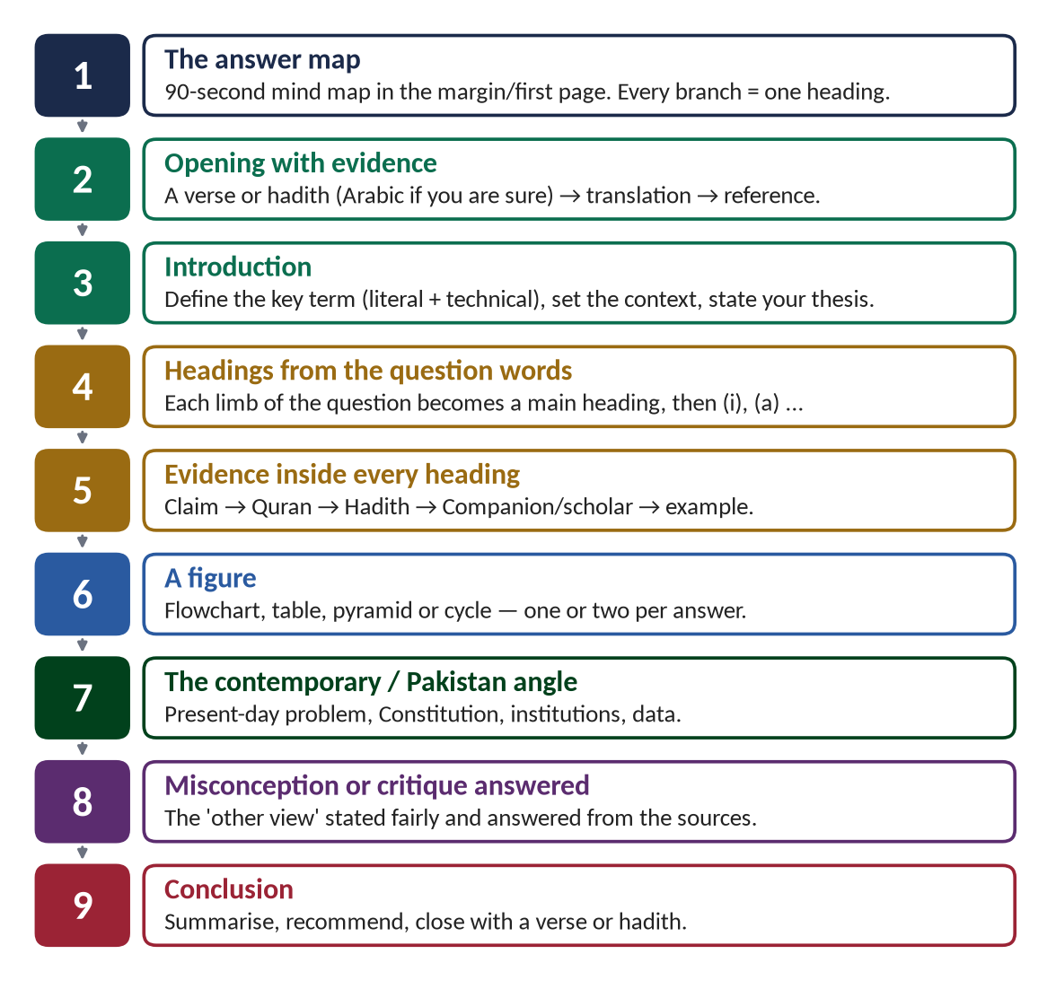
Figure 11 · The anatomy of a high-scoring Islamic Studies answer: nine moves, in order.

Move 1 — the answer map (90 seconds)
Draw a mind map with the question in the centre and one branch for each heading you will write. It is your plan, and it shows the examiner your structure before he reads a line (section 5.3).

Move 2 — opening with evidence
Begin with the verse or hadith that sums up the answer. Arabic if you are sure, then the translation in quotation marks, then (Surah, Quran) or (Collection).

Move 3 — the introduction (4–6 sentences)
Define the key term literally and technically; place it in the Islamic scheme; state your thesis — the one sentence the whole answer will prove.

Move 4 — headings from the question words
Every limb of the question becomes a main heading, in the question's own words. Under it, sub-headings (i), (ii)… and under those (a), (b)…

Move 5 — evidence inside every heading
Each heading follows the same pattern: claim → Quran → Hadith → Companion/scholar → example → one line of explanation. Never a heading without evidence.

Move 6 — a figure
At least one per answer: a comparison table, a flowchart of causes and effects, a pyramid, a cycle. Label it and refer to it.

Move 7 — the contemporary / Pakistan angle
A section that applies the teaching to today: the problem, the data, the Constitution, the institutions, the solution.

Move 8 — the misconception or critique answered
State the objection fairly (the Western critique, the extremist misreading, the cultural practice) and answer it from the sources.

Move 9 — the conclusion
Answer the question in three or four sentences, make one or two recommendations, and close with a verse or hadith.

5.3 The answer map — the house rule
Every answer in these notes begins with an answer map, and every answer you write in the exam should begin with one. It takes ninety seconds. It forces you to decide your headings before you write, it stops you from forgetting a limb of the question, and it shows the examiner your plan.
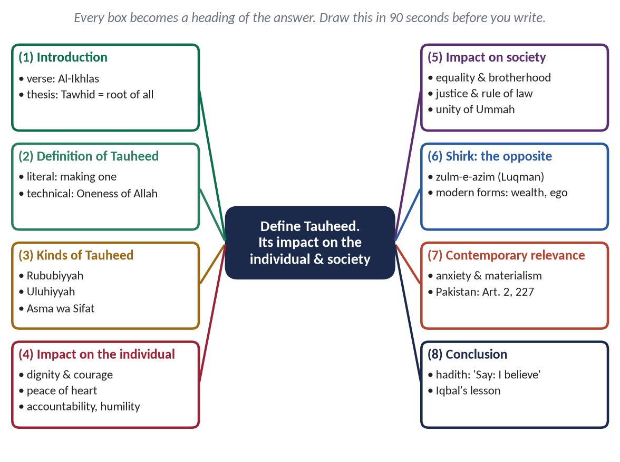
Figure 12 · An answer map for CSS 2019 Q2: 'Define Tauheed. What is its impact on individual life and the society?' Every box becomes a heading.

How to build it — five steps
1. Underline the command words and the limbs of the question: Define Tauheed · impact on individual · impact on society.
2. Write the question in the centre in your own short words.
3. One branch per limb, in the order of the question, using the question's words.
4. Add the standard branches: Introduction, the concept's kinds or background, the contemporary angle, the conclusion.
5. Write two or three sub-points under each branch — and the evidence you will use (just the surah name or hadith keyword).

5.4 The introduction that earns marks
The introduction does three things in four to six sentences: it defines, it places, and it promises.
Part | What to write | Example (Tauheed, 2019)
Opening evidence | The verse or hadith that sums up the answer | Say: He is Allah, the One … (Al-Ikhlas, Quran)
Definition | Literal meaning + technical meaning | Tauheed comes from wahhada, to make one; technically it is the belief that Allah is One in His essence, attributes, lordship and right to worship.
Place | Where it stands in Islam | It is the first article of faith, the message of every Prophet and the foundation of the whole Din.
Thesis | The one-sentence answer to the question | Tauheed does not only change what a person believes; it remakes the individual and reorganises society on equality, justice and freedom.

TRAP · THE INTRODUCTION THAT SAYS NOTHING
'Islam is a complete code of life. It covers every aspect of life. It is the religion of peace …' — these three sentences appear in thousands of scripts and earn nothing. Define the exact term of the question and state a thesis.

5.5 Headings that repeat the question
This is the single most important habit. The examiner is looking for the answer to his question; show it to him in the headings. The notes use a four-level heading ladder, and you should use the same ladder in the exam:
Level | Numbering | Used for | Example
1 | (1), (2), (3) … | Each limb of the question; introduction; conclusion | (4) Impact of Tauheed on the Individual
2 | (i), (ii), (iii) … | The main points under a limb | (i) Human dignity and self-respect
3 | (a), (b), (c) … | The aspects or examples of a point | (a) Freedom from bowing before any creature
4 | • | Short facts, data, names | • Bilal (RA): a slave who became the Prophet's muezzin

A worked heading tree — CSS 2019 Q2
Define Tauheed. What is its impact on individual life and the society? Elaborate.
- (1) Introduction — Al-Ikhlas; definition; thesis
- (2) Definition of Tauheed
- (i) Literal meaning
- (ii) Technical meaning
- (iii) Tauheed in the Quran and Sunnah
- (3) Kinds of Tauheed
- (i) Tauheed al-Rububiyyah — Oneness of Lordship
- (ii) Tauheed al-Uluhiyyah — Oneness of Worship
- (iii) Tauheed al-Asma wal-Sifat — Oneness of Names and Attributes
- (4) Impact of Tauheed on Individual Life
- (i) Dignity and self-respect
- (a) Freedom from bowing before any creature
- (b) Bilal (RA) and the slaves of Makkah
- (ii) Courage and fearlessness
- (iii) Contentment and peace of heart
- (iv) Humility and modesty
- (v) Sense of accountability and moral discipline
- (vi) Broad outlook and universal sympathy
- (vii) Optimism and freedom from despair
- (5) Impact of Tauheed on Society
- (i) Equality and brotherhood
- (ii) Justice and the rule of law
- (iii) Freedom from tyranny and exploitation
- (iv) Unity of the Ummah
- (v) Social and economic welfare
- (vi) Moral order and peace
- (6) Shirk: The Opposite of Tauheed and Its Damage
- (7) Tauheed and the Crises of Modern Man — materialism, anxiety; Pakistan: Articles 2 and 227
- (8) Conclusion — Iqbal; closing hadith

More examples: from question to headings
Question (year) | Main headings (level 1)
Motives of extremism in Pakistan; how to get rid of it (2023) | (1) Introduction (2) Extremism: meaning and the Islamic position (3) Motives of extremism in Pakistan — religious, political, economic, educational, external (4) Getting rid of extremism in the light of Islamic teachings — state, ulema, education, media, family (5) Paigham-e-Pakistan (6) Conclusion
Charter of Madinah as a social contract (2023) | (1) Introduction (2) Background (3) The concept of a social contract (4) The Charter's terms (5) The Charter as a social contract: parties, consent, rights, duties, sovereignty, justice (6) Comparison with Hobbes, Locke and Rousseau (figure) (7) Relevance for Pakistan (8) Conclusion
Ijma: kinds; can parliament's legislation be Ijma? (2023) | (1) Introduction (2) Definition of Ijma (3) Proofs of Ijma (4) Kinds of Ijma (5) Conditions of valid Ijma (6) Can parliamentary legislation be valid Ijma? — the case for, the case against, the balanced view (Iqbal; CII) (7) Conclusion
Rights of daughters; how they are denied (2023) | (1) Introduction (2) Daughters before Islam (3) Rights of daughters in Islam — life, upbringing, education, consent, inheritance, dignity (4) How these rights are denied today (5) Remedies (6) Conclusion

5.6 Evidence — how to use the Quran and Hadith in the exam
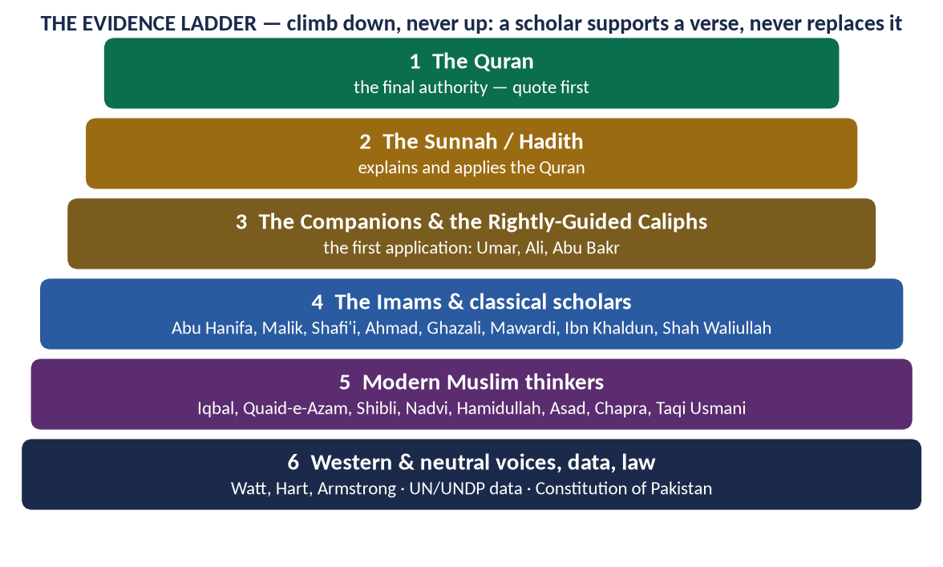
Figure 13 · The evidence ladder: the order in which evidence is used, and its weight.

The rules of evidence
1. Quran first. Put the strongest verse at the head of the point.
2. Arabic only if you are certain. Write it neatly, with its vowel marks if you know them, on its own line. If in doubt, write only the translation.
3. Translation in quotation marks, in simple English.
4. Reference in brackets: (Al-Hujurat, Quran); (Al-Bukhari).
5. Then the point it proves — one sentence tying the evidence to the heading. A quotation without this sentence earns half its value.
6. Quantity: a twenty-mark answer needs roughly 6–10 verses, 4–6 ahadith and 2–4 other authorities. Spread them — at least one piece of evidence under every main heading.
7. Companions and history are evidence too: Hazrat Umar's dealings with his governors, the Charter of Madinah, the Conquest of Makkah.

Which scholars to quote
Group | Safe, widely respected names | Typical use
Classical imams and jurists | Imam Abu Hanifa, Imam Abu Yusuf, Imam Malik, Imam Shafi'i, Imam Ahmad bin Hanbal | Fiqh, Ijtihad, Ijma, governance (Kitab al-Kharaj)
Classical thinkers | Imam Ghazali, al-Mawardi, Ibn Khaldun, Shah Waliullah, Mujaddid Alf Thani | Tazkiyah, maqasid, governance, civilization, reform
Modern Muslim thinkers | Allama Iqbal, Quaid-e-Azam, Sir Syed, Shibli Nomani, Syed Sulaiman Nadvi, Dr Hamidullah, Muhammad Asad, Khurshid Ahmad, Umer Chapra, Dr Mahmood Ahmad Ghazi, Mufti Taqi Usmani | Sirah, constitution, Ijtihad, economics, Islam and the West
On the FPSC list | the authors in section 1.3, including Mawdudi (for the concepts his listed books explain) | Din, Khilafat, Islamic law and constitution
Western and neutral voices | W. Montgomery Watt, Michael Hart, Lamartine, Karen Armstrong, John Esposito, Robert Briffault, Philip Hitti, Annemarie Schimmel | Sirah, impact on the West, Islamophobia

TRAP · FAKE QUOTATIONS
Many 'quotations' in circulation are invented or wrongly attributed — to Western writers praising the Prophet ﷺ, to Hazrat Ali, to Iqbal. If you cannot trace it, paraphrase it and drop the quotation marks. These notes quote directly only when the words are well attested; otherwise they summarise the view.

5.7 Figures in an Islamic Studies answer
A figure is not decoration. It shows a relationship that text takes a paragraph to explain — and examiners notice it immediately. Aim for one or two per answer, drawn with a ruler and labelled.
Figure | When to use it | Example
Comparison table | Any 'compare', 'differentiate', 'critical analysis' | Din vs religion; Islam vs UDHR; Islamic vs capitalist vs socialist economy
Flowchart (cause → effect) | Causes and consequences; 'how can…' | Causes of extremism → effects → solutions
Tree / mind map | Kinds, branches, classifications | Kinds of Tauheed; kinds of Ijma; heads of Zakat
Pyramid / ladder | Hierarchies and sources | Sources of Islamic law; the levels of Din
Cycle | Processes that reinforce themselves | Zakat → purchasing power → trade → growth → more Zakat
Time-line | Sequences and phases | The Ghazwat; phases of terrorism in Pakistan

Twelve master figures to practise
1. Din: Iman–Islam–Ihsan (Hadith of Jibril)
2. Din vs religion comparison table
3. The three kinds of Tauheed
4. The eight heads of Zakat and the Zakat cycle
5. The spiritual–moral–social impact triangle of worship
6. The five roles of the Prophet ﷺ (the syllabus wheel)
7. The Ghazwat time-line with outcome and lesson
8. Charter of Madinah vs Hobbes–Locke–Rousseau
9. Islam vs UDHR
10. Causes → solutions of extremism flowchart
11. Sources of Islamic law pyramid
12. Islamic economic system: prohibitions, obligations, institutions

5.8 The contemporary and Pakistan angle
The examiner is a senior officer or scholar of the Pakistani state setting a paper for future officers. An answer that connects Islam to Pakistan's Constitution, institutions and problems shows that you can think like an officer. Learn this table; it fits into half the questions of the paper.
Provision / institution | What it says or does | Use in
Objectives Resolution (1949); Article 2A | Sovereignty belongs to Allah; authority is a sacred trust exercised by the people's representatives within the limits prescribed by Allah; made a substantive part of the Constitution in 1985. | T1, T8, T9
Article 2 | Islam shall be the State religion of Pakistan. | T1, T6
Article 31 | Islamic way of life: teaching of the Quran and Islamiat, Arabic, proper organisation of Zakat, Ushr, Auqaf and mosques, promotion of Islamic moral standards. | T2, T5, T9
Article 37 · Article 38 | Promotion of social justice and eradication of social evils; economic well-being of the people; 38(f): elimination of riba (by 1 January 2028 after the 26th Amendment, 2024). | T5, T9
Article 40 | Strengthening bonds with the Muslim world and promoting international peace. | T6
Article 227 | All existing laws to be brought in conformity with the Quran and Sunnah; no law repugnant to them. | T8, T9
Articles 228–230 | The Council of Islamic Ideology: advises Parliament on the Islamic character of laws — a model of collective Ijtihad. | T9
Article 203C | The Federal Shariat Court: may examine whether a law is repugnant to Islam; its 2022 judgment declared the interest-based system against the Shariah. | T9
Article 260(3) | Defines 'Muslim' with reference to belief in the absolute finality of the Prophethood of Muhammad ﷺ. | T1
Zakat and Ushr system (1980) | State collection and distribution of Zakat; a subject of reform debates. | T2
National Action Plan (2014) · Paigham-e-Pakistan (2018) | The state's and the ulema's joint response to terrorism, sectarianism and hate speech. | T7

5.9 Sensitive questions — how to stay safe
- Never name a sect, a school or a living personality negatively. Criticise an idea or a practice, not a group.
- Present the agreed position of the Muslim scholars; where the schools differ, say so respectfully and give the Hanafi view as the majority view in Pakistan.
- Admit real problems honestly — denial of inheritance, extremism, corruption — and blame the practice, not the religion.
- Do not attack the West as a whole; distinguish its achievements (science, rule of law, welfare) from its problems (materialism, family breakdown, Islamophobia).
- On international conflicts (Kashmir, Palestine), state facts and principles — the right of self-determination, the sanctity of life — without abuse.

5.10 Short notes — ten marks each
When Q. 8 asks for two notes (2021, 2023, 2024), each is half an answer: about 600–800 words, 45 minutes for the pair.
1. Definition / background in three or four lines, with one verse or hadith.
2. Four to six headed points, each with a piece of evidence or a fact.
3. One small figure or table if it fits.
4. One-line conclusion.

5.11 Twelve mistakes that cost marks
1. Writing on the topic instead of the question.
2. No headings, or generic headings.
3. A wrong verse, a wrong surah, or a weak hadith presented as sound.
4. Arabic written carelessly or incorrectly.
5. Evidence listed at the end instead of inside the points.
6. One limb of the question ignored.
7. A sermon instead of an argument — feelings instead of reasons.
8. No contemporary or Pakistan angle in an applied question.
9. Attacking a sect, a personality or a country.
10. The fourth answer written in fifteen minutes.
11. Blank pages left between answers (forbidden by the printed instructions).
12. No conclusion — or a conclusion that repeats the introduction.

5.12 The objective part in thirty minutes
- Read each MCQ once; answer at once if you know it; mark and return if you do not. Do not change an answer without a clear reason.
- Most MCQs are Sirah, Quran and Companions (section 3.8): learn the One-Liner Bank of each topic, and the repeated facts first.
- Watch the options 'None of these' and 'All of the above' — several recent keys have been 'None of these'.
- Do not leave any item blank.

Part Six — The Plan

6.1 A sixteen-week plan
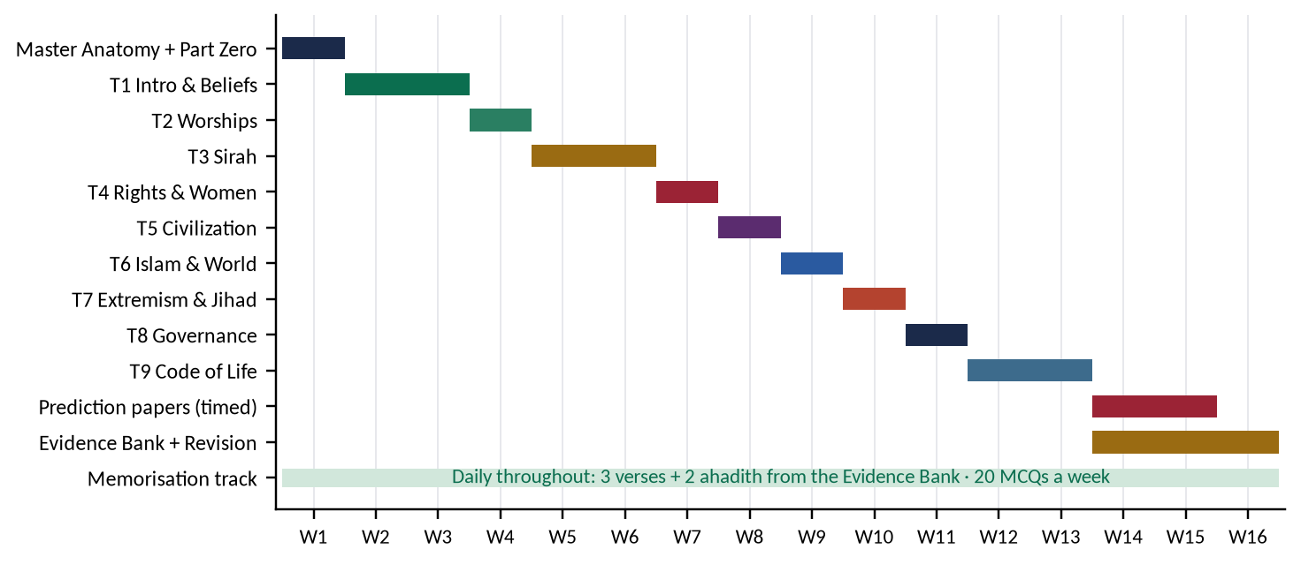
Figure 14 · A sixteen-week plan for Islamic Studies, alongside your other papers.
Weeks | Work | Output
1 | This Master Anatomy; Part Zero twice; glossary | Can explain the nine topics and the method
2–3 | T1 (Beliefs): KB reading ×2; QA | Four practice answers; evidence cards memorised
4 | T2 (Worships) | Two practice answers
5–6 | T3 (Sirah) — the heaviest topic | Four practice answers
7 | T4 (Rights and women) | Three practice answers
8 | T5 (Civilization) | Two practice answers
9 | T6 (Islam and the World) | Two practice answers
10 | T7 (Extremism and Jihad) | Two practice answers
11 | T8 (Governance) | Two practice answers
12–13 | T9 (Code of life and sources) | Three practice answers
14–15 | Prediction Papers Sets 1–3 under exam conditions (3 hours each); correct against the model answers | Three full papers
16 | Evidence Bank and Revision Notes; the repeat families; the blind spots | Ready

6.2 How to use each document

The Knowledge Base, in three readings
1. First reading — understand. Read straight through; do not memorise. Read the figures carefully.
2. Second reading — mark. Mark the evidence cards you will memorise (three to five per chapter) and the headings you will reuse.
3. Third reading — recall. Cover the page; reproduce the headings of each chapter and the evidence under each.

The Question Answers, in three passes
1. Pass one — study the build: the answer map, the decoding, the headings.
2. Pass two — write it yourself, closed book, in 33 minutes, from the answer map only.
3. Pass three — compare your answer with the model: which heading did you miss, which evidence did you forget?

6.3 Memorising the verses and ahadith
1. Three verses and two ahadith a day from the Evidence Bank (or the evidence cards of the topic you are reading).
2. Learn the meaning first, then the Arabic. Say the translation aloud; then read the Arabic three times; then write it once from memory.
3. Learn each piece with its 'point' — the sentence after the arrow. A verse you cannot use is a verse you have not learnt.
4. Revise on a 1–3–7 rhythm: the next day, three days later, a week later.
5. Build a personal list of about 60 verses and 40 ahadith that you can write with certainty. That is enough for any paper.
REMEMBER · QUALITY OVER QUANTITY
Ten verses you can write correctly and use precisely are worth more than a hundred you half-remember. One misquoted verse can cost more than it earns.

6.4 The last fortnight
- Re-read Part Three of this document: the repeat engine, the blind spots and the tiers.
- Write one full timed paper every third day (the three Prediction Papers).
- Revise from the Revision Notes and the Evidence Bank only — no new material.
- For each Tier 1 family, rehearse the answer map from memory.

6.5 The day of the paper
1. Part I: 30 minutes, every MCQ answered.
2. Read all seven questions; choose four you can answer fully in every limb — not the four you like most.
3. Draw the four answer maps first (10 minutes). If a map does not fill, change the question now, not after 20 minutes of writing.
4. Write in the order of your confidence: best answer first.
5. Keep to 33 minutes per answer. At the limit, write the conclusion and move on.
6. Last 8 minutes: check numbering, headings and references; cross any blank page.

6.6 After the nine topics
When the nine topics are finished, the five compiled volumes — the Evidence Bank, the Question Answers print volume, the One-Liner and MCQ Bank, the Revision Notes and the Prediction Papers — become your working set for the final month. This Master Anatomy stays at the front of the file.

Appendix A — Every Descriptive Question, 2015–2026, by Year

2015 — old scheme: attempt five of eight, 16 marks each
Q | Question | Topic | Family
Q2 | Explain the concept and structure of the Muslim Ummah and give suggestions for its revival. | T6 | Ummah & challenges
Q3 | What is the difference between Jihad and Fasaad (Hostility)? Discuss the possibilities of practical application of Quranic concept of Jihad in current international scenario. | T7 | Jihad
Q4 | The entire faith in Prophethood is unacceptable without faith in finality of the Prophethood. Discuss in the light of Quran & Sunnah. | T1 | Prophethood & Finality
Q5 | Highlight the importance of Zakat and prove that economic stability of a society can be ensured through its effective implementation. | T2 | Zakat
Q6 | Write a comprehensive note on the importance of Sunnah in interpretation and legislation. | T9 | Sources: Sunnah, Ijma, Ijtihad
Q7 | Argue for supremacy of 'Wahi' as the solution of human problems against other sources of knowledge. | T1 | Wahi
Q8 | Stability of modern society depends upon a strong family system in the light of Islamic principles. Discuss. | T4 | Family
Q9 | Give a comparison of Islamic ideology and modern Western thought about present trends of individuality. | T6 | Islam & the West

2016 — attempt four of seven, 20 marks each
Q | Question | Topic | Family
Q2 | What is meant by culture and civilization? Describe the characteristics of Islamic culture. | T5 | Civilization: meaning & characteristics
Q3 | What is the difference between Deen and Religion? Describe the importance of Deen in human life with arguments. | T1 | Din & Religion
Q4 | Describe the characteristics of Military strategist in the light of Sirah of Muhammad (PBUH) with arguments. | T3 | Military strategist
Q5 | Define the meaning of prayer and its different categories. Also describe the spiritual, moral and social impact of prayers. | T2 | Salah
Q6 | Highlight the concept of Public Administration in Islam. Explain the responsibilities of Civil Servants. | T8 | Civil servants & public administration
Q7 | Discuss the salient features of Islamic political system in the light of governance under pious Khilafat-i-Rashida. | T8 | Khilafat & political system
Q8 | What are the contemporary challenges of Muslim world? Suggest its solutions in the light of Quran and Sunnah? | T6 | Ummah & challenges

2017 — attempt four of seven, 20 marks each
Q | Question | Topic | Family
Q2 | Who are entitled to receive Zakat according to the Quran? Elucidating social impact of Zakat, clarify how can poverty be alleviated with its distribution in Islamic Society? | T2 | Zakat
Q3 | Write a comprehensive note on the right of inheritance granted to women by Islam. | T4 | Women's rights
Q4 | How were the Rightly-guided Caliphs elected? To what extent their system of government be regarded as democratic? | T8 | Khilafat & political system
Q5 | Elucidate how the Prophet of Islam (Peace be upon him) exemplified him as the greatest peace maker in the world by making reconciliation with pagans, Jews and Christians? | T3 | Peace maker
Q6 | Explain the concept of self-purification in the light of the Qur'ān and Sunnah and its impact on society. | T5 | Self-purification & Sufism
Q7 | Enumerate the reasons of extremism in Pakistan and suggest solutions to eradicate it in the light of Islamic teachings. | T7 | Extremism & terrorism in Pakistan
Q8 | Define Ijma' (consensus) and explain its different kinds. Highlight its importance in the light of the Qur'ān and Sunnah. | T9 | Sources: Sunnah, Ijma, Ijtihad

2018 — attempt four of seven, 20 marks each
Q | Question | Topic | Family
Q2 | Define Ijtihad, also highlight its contemporary importance in the light of Islamic Fiqh. | T9 | Sources: Sunnah, Ijma, Ijtihad
Q3 | What is Self-purification and Ehsan? Explain it in the light of Quran and Sunnah, also describe its individual and collective impacts. | T5 | Self-purification & Sufism
Q4 | Point out the motives of terrorism in Pakistan. How can the society get rid of terrorism? | T7 | Extremism & terrorism in Pakistan
Q5 | Highlight the responsibilities of civil servants in the light of Islamic teachings. | T8 | Civil servants & public administration
Q6 | Write a comprehensive note on Zakat system of Islam and its spiritual, moral and social impacts. | T2 | Zakat
Q7 | Describe, in detail, the basic characteristics of Islamic civilization. | T5 | Civilization: meaning & characteristics
Q8 | The Holy Prophet (PBUH) is the prophet of peace and safety. Explain with arguments. | T3 | Peace maker

2019 — attempt four of seven, 20 marks each
Q | Question | Topic | Family
Q2 | Define Tauheed. What is its impact on individual life and the society? Elaborate. | T1 | Tawhid
Q3 | Give a general estimate of Holy Prophet's (PBUH) character in the battle fields as commander. | T3 | Military strategist
Q4 | Describe the rights of women in Islam in the context of current wave of the feminist movement. | T4 | Women's rights
Q5 | Throw light in detail on the moral value system of Islam as a significant feature of Islamic civilization. | T5 | Civilization: meaning & characteristics
Q6 | Write a comprehensive note on Hajj (the pilgrimage) system of Islam and its spiritual, moral and social impacts. | T2 | Hajj
Q7 | Is extremism a challenge to Islam? Discuss in the context of contemporary challenges faced by Muslim Ummah. | T7 | Extremism & terrorism in Pakistan
Q8 | Give suggestions to reform Pakistani Politics keeping in view the different aspects of political system of Islam. | T8 | Khilafat & political system

2020 — attempt four of seven, 20 marks each
Q | Question | Topic | Family
Q2 | Discuss the status and grade of "Tolerance and Forgiveness" in the life of the Holy Prophet (PBUH). | T3 | Character: tolerance & morals
Q3 | Write a comprehensive note on the bravery and juridical wisdom of Hazrat Ali (R.A). | T8 | Khilafat & political system
Q4 | "The last Sermon of the Holy Prophet (PBUH) is the basic document for awakening of conscience of mankind for human rights". Discuss. | T4 | Human rights & dignity
Q5 | Discuss in detail the principles and terms & conditions for "Jihad" in the light of Quran and Sunnah. | T7 | Jihad
Q6 | Analyze the Madina Accord as a "Social Contract" in detail. | T3 | Charter of Madina
Q7 | "Islam teaches the lesson of human respect and dignity irrespective of colour, race and creed". Discuss. | T4 | Human rights & dignity
Q8 | "Islamic Financial and Economic system is the solution of the human financial problems". Discuss. | T9 | Economic system

2021 — attempt four of seven, 20 marks each
Q | Question | Topic | Family
Q2 | What is belief in the Day of Judgment? Explore its effects on individual and collective lives of human beings. | T1 | Akhirah
Q3 | Islam provides better rights to men and women than all other religions. Explore with arguments. | T4 | Women's rights
Q4 | Comment on the teachings of Islam regarding co-existence in a multi-faith society. | T6 | Co-existence & tolerance
Q5 | Islamophobia is a sign of extremism. Give suggestions for its remedy. | T6 | Islamophobia
Q6 | Express the principles of accountability of rulers according to the Holy Quran and Sunnah. | T8 | Accountability (Hisbah)
Q7 | Explore the importance of Sufism to spread out Islam. Is the amelioration of current deviation possible through Sufism? | T5 | Self-purification & Sufism
Q8 | Write notes on the following: (a) Treaty of Hudaybiyya as a pact of peace; (b) Benefits acquired from the Battle of Khaybar. | T3 | Peace maker

2022 — attempt four of seven, 20 marks each
Q | Question | Topic | Family
Q2 | Explain the concept of Human Rights in Islamic thought in specification of "Status of Women in Islam". | T4 | Women's rights
Q3 | Write down the main principles of Islamic Economics. How do these principles provide solutions to contemporary challenges? | T9 | Economic system
Q4 | Elaborate the concept and importance of Ijtihad and explain its principles. | T9 | Sources: Sunnah, Ijma, Ijtihad
Q5 | Explain the doctrine of Prophethood and its importance in human life. | T1 | Prophethood & Finality
Q6 | Describe Hazrat Muhammad (ﷺ) as a Prophet of Peace for contemporary transnational world. | T3 | Peace maker
Q7 | Explain the Reconstruction of Pakistani Society in the light of Islamic Teachings. | T6 | Pakistan & Islam
Q8 | Describe the importance of Deen (Doctrine of life) in human life. Differentiate between Deen and Religions. | T1 | Din & Religion

2023 — attempt four of seven, 20 marks each
Q | Question | Topic | Family
Q2 | What is the Qur'anic argument on the Life Hereafter? What are its impacts on the individual and collective life of a human being? | T1 | Akhirah
Q3 | Discuss the Holy Prophet's (ﷺ) Role as a Model for Military Strategy. | T3 | Military strategist
Q4 | Elaborate the rights of daughters granted by Islam and how these are denied by Muslims in the contemporary world? | T4 | Women's rights
Q5 | Define Ijma (consensus) and explain its different kinds. Can legislation by a parliament of an Islamic state be regarded as a valid consensus? | T9 | Sources: Sunnah, Ijma, Ijtihad
Q6 | Analyze the Charter of Madina as a social contract. | T3 | Charter of Madina
Q7 | What are the motives of extremism in Pakistan? How can the society get rid of extremism by following the teachings of Islam? | T7 | Extremism & terrorism in Pakistan
Q8 | Write notes on the following: (i) Human rights in the light of the Sermon of the Farewell Pilgrimage; (ii) Social justice in an Islamic society. | T4 | Human rights & dignity

2024 — attempt four of seven, 20 marks each
Q | Question | Topic | Family
Q2 | Self-purification is an essential element for the evolution of society. Explain. | T5 | Self-purification & Sufism
Q3 | The main purpose of Ghazwat-e-Nabawi was to establish peace. Explain. | T3 | Military strategist
Q4 | Explain the doctrine of Prophethood and its importance in human life. | T1 | Prophethood & Finality
Q5 | How does Islam highlight human dignity and greatness? Discuss. | T4 | Human rights & dignity
Q6 | How can the system of accountability in Pakistan be idealized in the teachings of the Holy Prophet (ﷺ)? Explain. | T8 | Accountability (Hisbah)
Q7 | How is it possible to eliminate the religious and political extremism in Pakistan in the light of the teachings of the Holy Prophet (ﷺ)? Explain. | T7 | Extremism & terrorism in Pakistan
Q8 | Write notes on the following: (the two parts could not be recovered from any accessible archive). | — | Short notes (parts not recovered)

2025 — attempt four of seven, 20 marks each
Q | Question | Topic | Family
Q2 | What is the importance of Makarim Akhlaq (noble morals) in establishing social peace? In this background, how did the Messenger of Allah complete these morals? | T3 | Character: tolerance & morals
Q3 | What is meant by Farz Kifayah? What is its religious and social significance? In the present era, which affairs are considered to be included in the scope of Farz Kifayah? | T2 | Fard Kifayah
Q4 | Determine the status of the classist lifestyle in the light of the teachings of Islam and examine its effects on human society. | T5 | Equality & social justice
Q5 | What are the disadvantages of concentration of wealth? What economic measures has Islam introduced to prevent this concentration of wealth? | T9 | Economic system
Q6 | Discuss the contents of the peace agreements made during the Prophet's era, identifying the parties to those agreements. | T3 | Peace maker
Q7 | Discuss religious tolerance in the context of post-Prophetic Muslim history. | T5 | Tolerance in Muslim history
Q8 | What views are found in today's Muslim circles about Western Civilization? Identify and analyze them. | T6 | Islam & the West

2026 — attempt four of seven, 20 marks each
Q | Question | Topic | Family
Q2 | Provide a comparative and critical analysis of the human rights granted by Islam with those enshrined in the Universal Declaration of Human Rights (UDHR). | T4 | Human rights & dignity
Q3 | In the light of the plight of Indian and Kashmiri Muslims, discuss the justification and demands of the Two-Nation Theory. | T6 | Pakistan & Islam
Q4 | Explain how Western civilization has influenced Islamic civilization. Discuss the measures to protect Muslim societies from the negative impacts of Western culture. | T6 | Islam & the West
Q5 | What are the rational arguments for the existence of Allah? Explain the impacts of the belief in monotheism on human life. | T1 | Tawhid
Q6 | Explain the concept of accountability in the Islamic system. Demonstrate with examples that the practices of the Rashidun Caliphs in this perspective set the highest standard. | T8 | Accountability (Hisbah)
Q7 | Examine the causes of sectarianism and polarization in the Muslim World. Suggest solutions in the light of Islamic teachings. | T7 | Extremism & terrorism in Pakistan
Q8 | What are the challenges for the 'institution of family and its role' in the present era? Discuss them in the light of Islamic teachings. | T4 | Family

Appendix B — The Prediction Paper Format
Each of the three Prediction Papers is set exactly as FPSC prints the Islamic Studies paper, so that practising with them is practising for the real thing. This is the skeleton every set follows:
Element | As printed
Heading | FEDERAL PUBLIC SERVICE COMMISSION · COMPETITIVE EXAMINATION FOR RECRUITMENT TO POSTS IN BS-17 UNDER THE FEDERAL GOVERNMENT, 2027 · Roll Number box
Subject line | ISLAMIC STUDIES
Time and marks | TIME ALLOWED: THREE HOURS · PART-I (MCQS): MAXIMUM 30 MINUTES · PART-II: MAXIMUM 2 HOURS & 30 MINUTES · PART-I (MCQS) MAXIMUM MARKS = 20 · PART-II MAXIMUM MARKS = 80
Notes | (i) Part-II is to be attempted on the separate Answer Book. (ii) Attempt ONLY FOUR questions from PART-II. ALL questions carry EQUAL marks. (iii) All the parts (if any) of each question must be attempted at one place instead of at different places. (iv) Write Q. No. in the Answer Book in accordance with Q. No. in the Q. Paper. (v) No page/space be left blank between the answers. All the blank pages of Answer Book must be crossed. (vi) Extra attempt of any question or any part of the question will not be considered.
Part I | Q. No. 1: twenty MCQs (i)–(xx), four options (A)–(D) each, one mark each; answered on the separate MCQ answer sheet.
Part II | Q. No. 2 to Q. No. 8: seven questions, 20 marks each; usually one of them is 'Write notes on the following' (10 + 10).
After each set | The MCQ answer key; then a full model answer to every Part II question, built by the method of Part Five.

Across the three sets, the 21 descriptive questions are chosen so that every topic appears at least twice, every Tier 1 family appears, and the major blind spots of section 3.6 are covered.

Appendix C — Sources and Editorial Note
- The syllabus: FPSC, Revised Scheme and Syllabus for CSS Competitive Examination (CE-2016 and onwards), Islamic Studies, in English and Urdu, with the Required and Recommended Readings.
- The descriptive record: the compiled CSS Islamic Studies descriptive papers, 2015–2026 (85 questions). The short-note parts of 2021 and 2023 were recovered from public past-paper archives and solved-paper collections; the two parts of the 2024 short-notes question could not be recovered from any archive accessible when this edition was prepared and are marked as such. If you have the printed 2024 paper, the two parts can be added without changing any count except that question's topic.
- The objective record: the compiled CSS Islamic Studies MCQs, 2015–2026 (223 items; ten recovered for 2016 and thirteen for 2020).
- Question wording: minor spelling and punctuation have been regularised; the substance of no question has been changed.
- The Quranic text is printed from a verified digital Uthmani text; the English is a standard simple-English rendering of the meaning (Saheeh International). A translation is an explanation of meaning, not the Quran itself.
- Ahadith are quoted from the standard collections named in each reference.
- This document is an independent study guide. It is not an official publication of the Federal Public Service Commission.

